**Practice Assignment on Amazon AWS**

**Create an ec2 instance with the ubuntu operating system, set all the required parameters such as security groups and key pair, and also do SSH with git bash to the running instance.**

**Also, install NodeJS on top of the instance and check for the version of node to cross-check if NodeJS is installed successfully.**

**Login to the AWS management console.

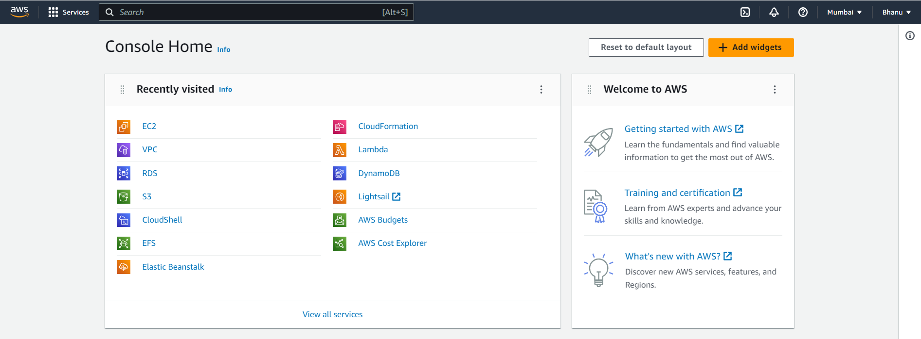

Step1:click on launch instance

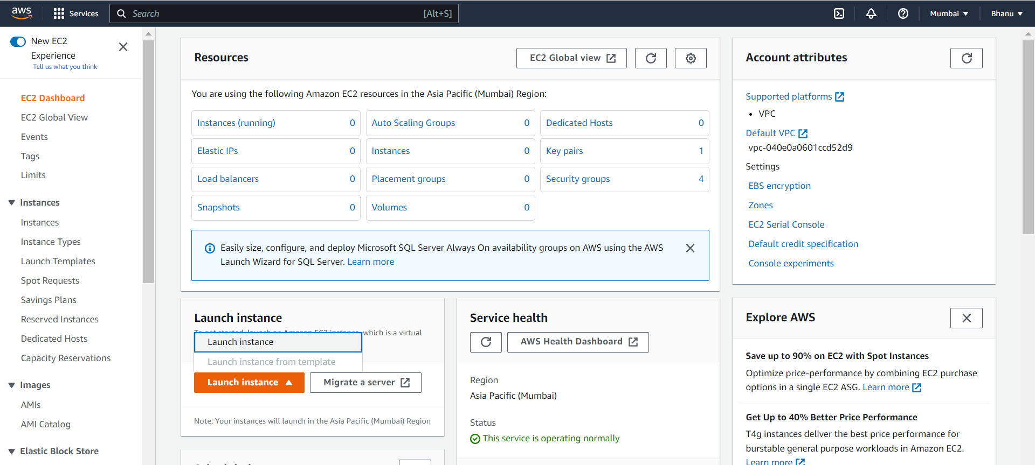

Step2:Give the name for the instance.

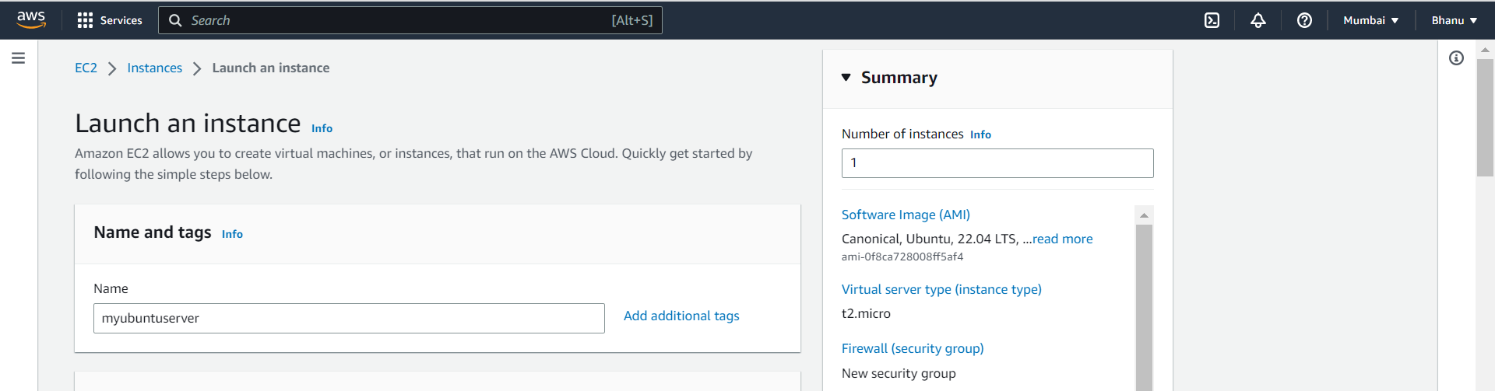

Step3:Select the ubuntu Amazon machine image

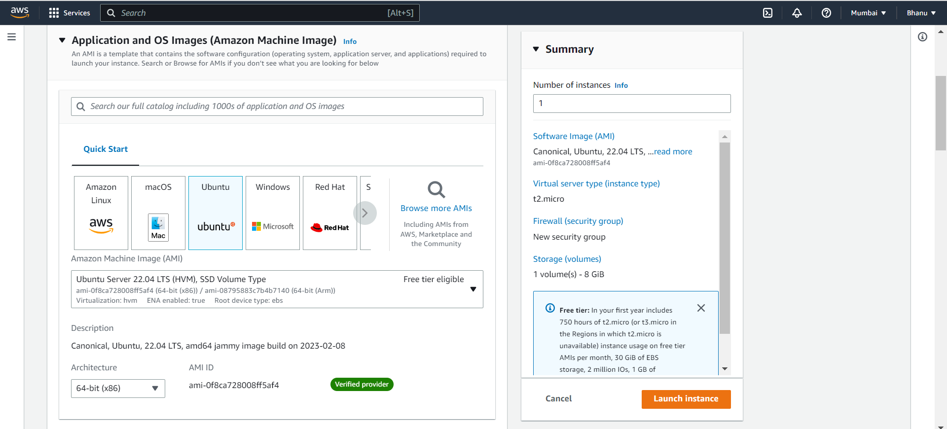

Step4:The instance type is t2.micro

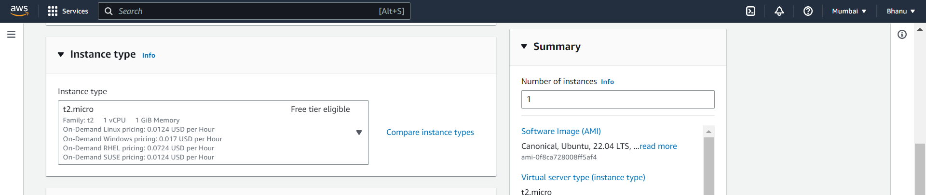

Step5:Create a key pair with name ubuntu and it is of .pem format

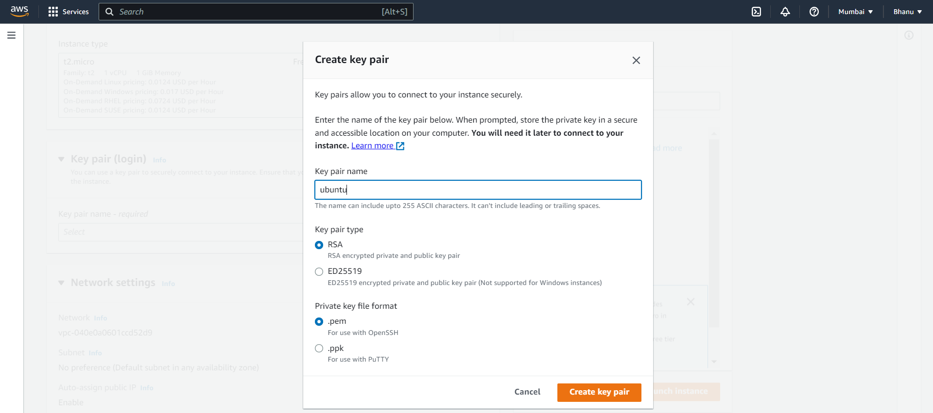

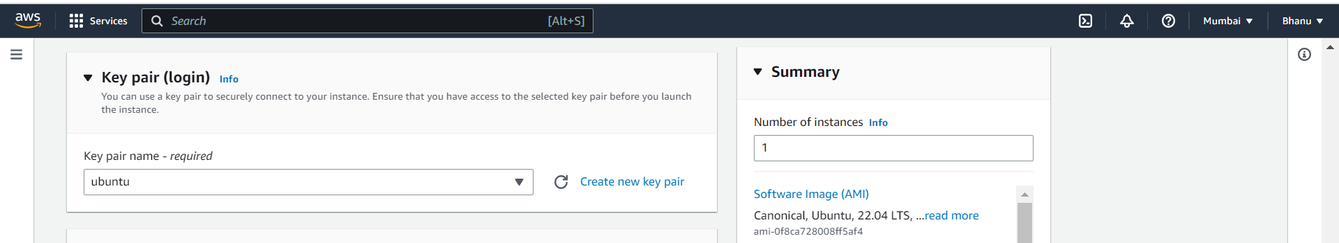

Step6:Use the default vpc and subnet,enable the auto assign public ip.

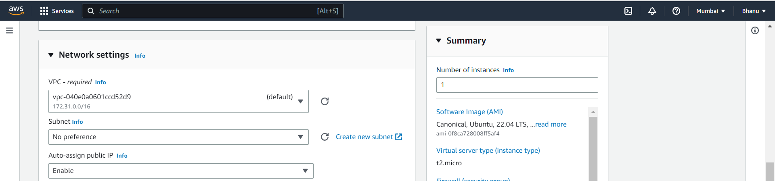

Step7:Create a security group and enable the ssh port,http port and https port.

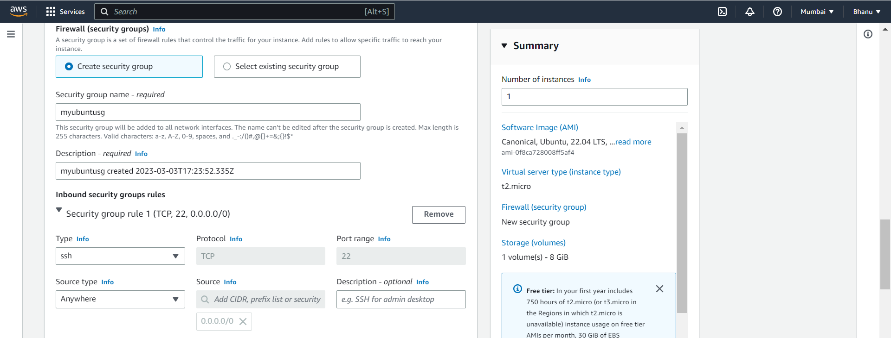

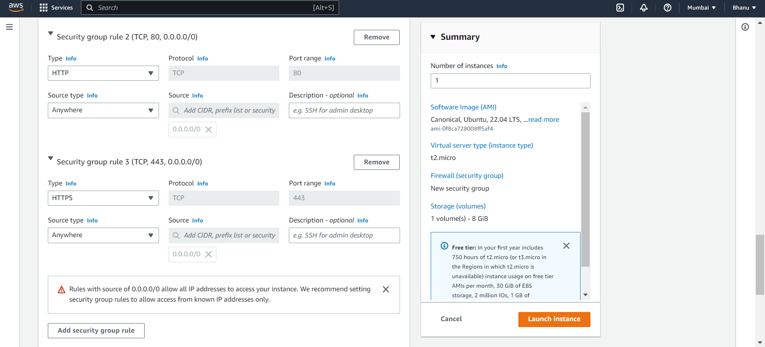

Step8:Keep the storage settings default.

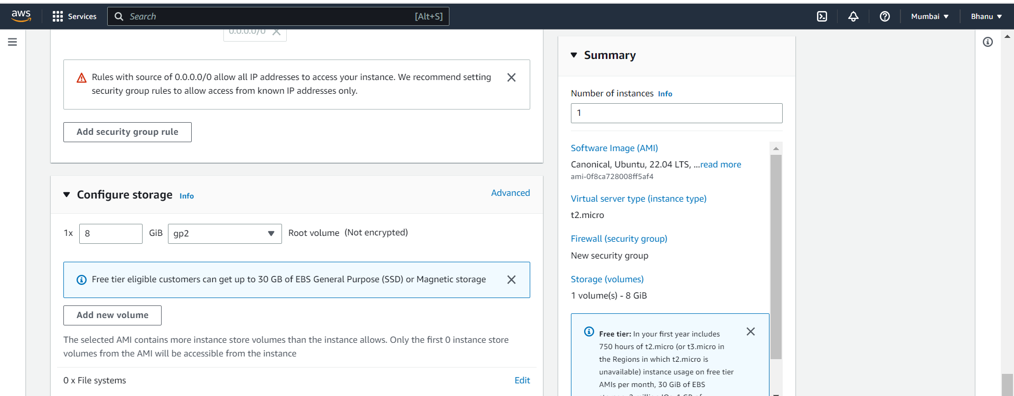

Step 9:Click on launch instance.

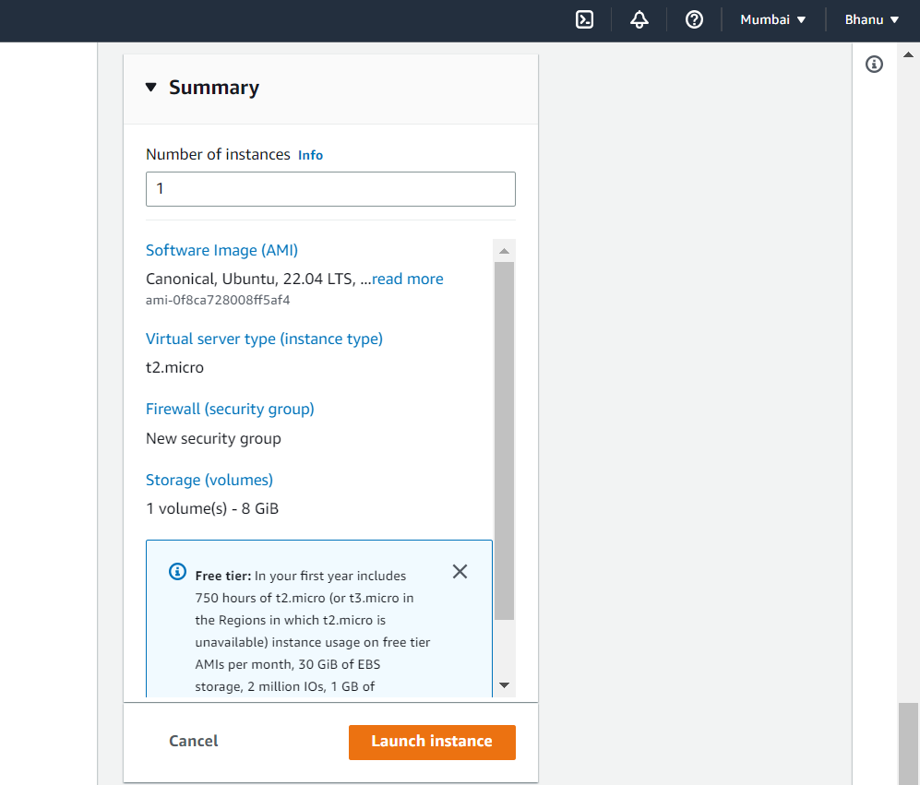

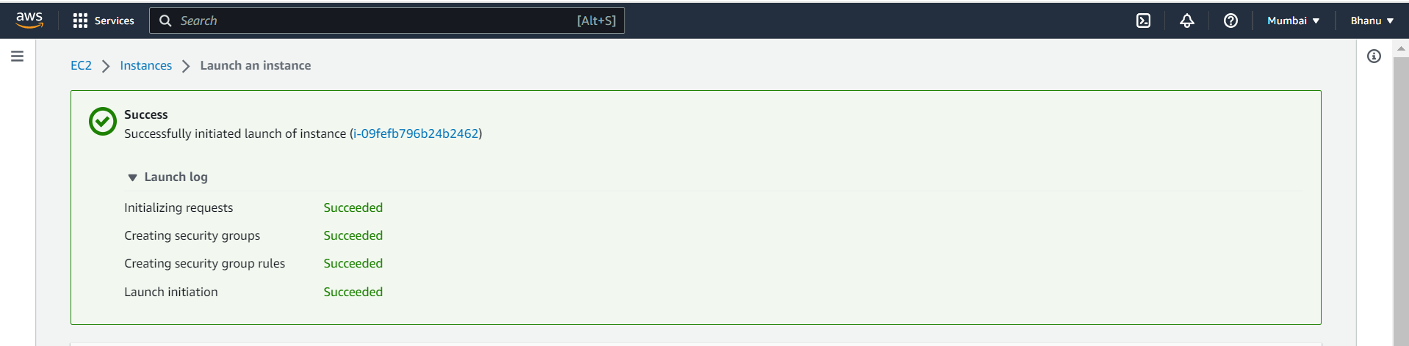

Step10:The instance is launched successfully and it is now running.

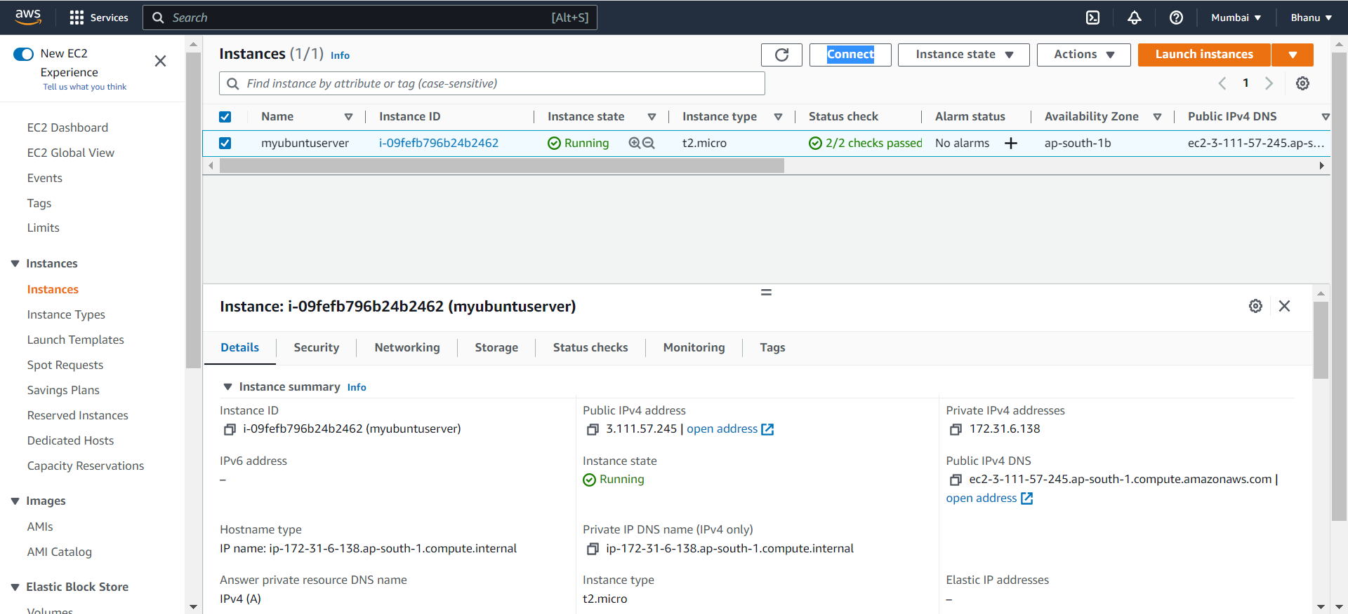

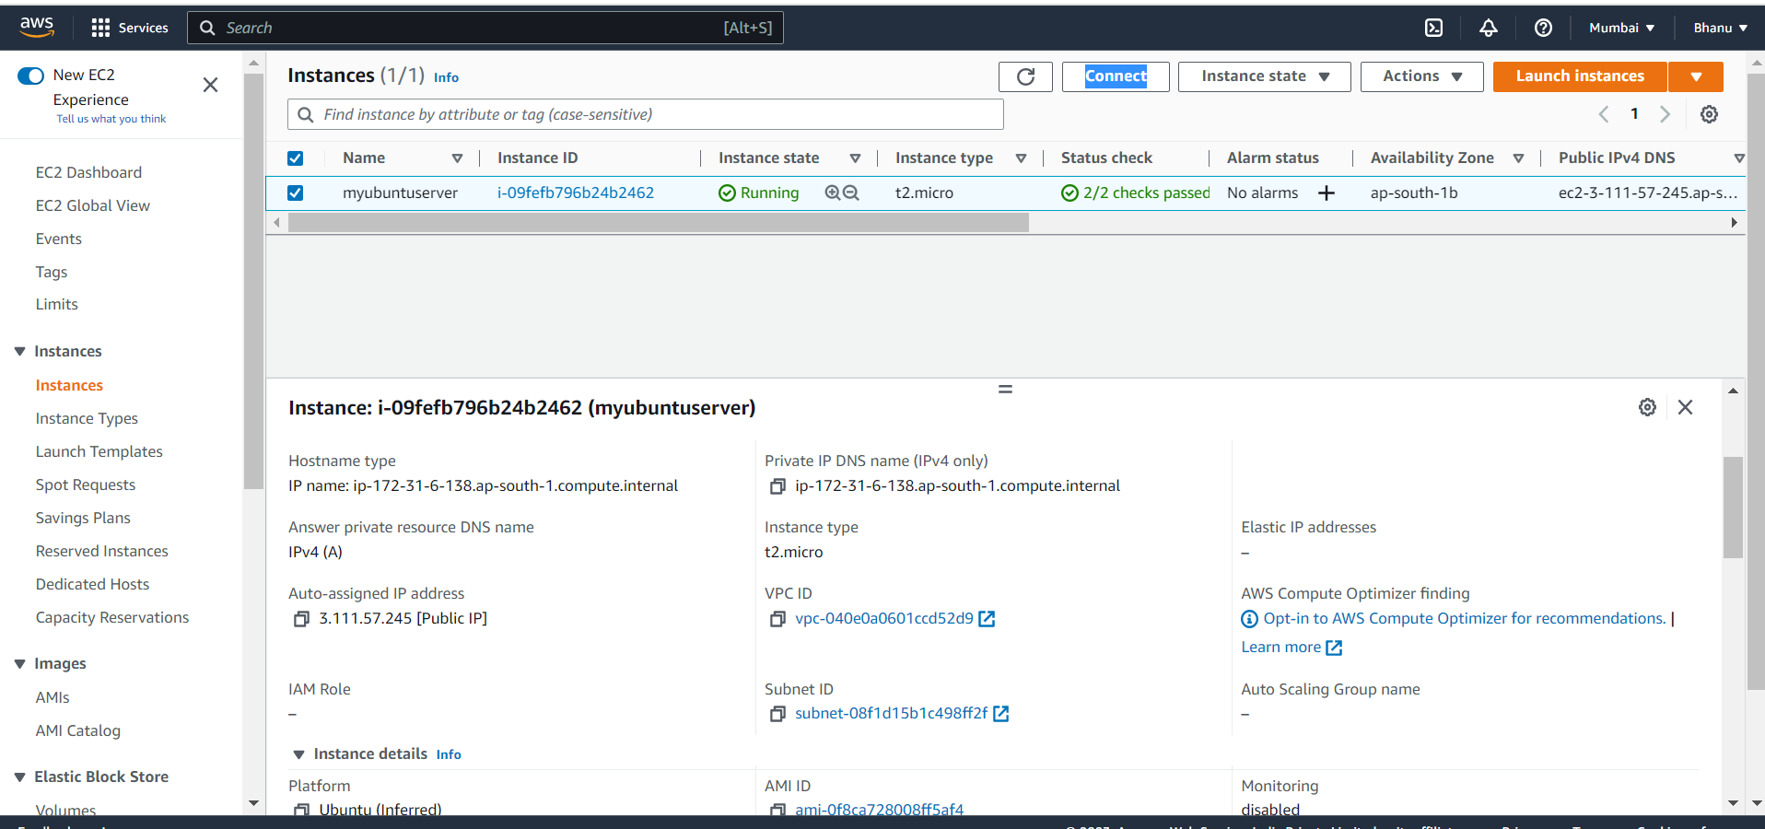

Step11:select the instance and choose connect.

Copy the ssh

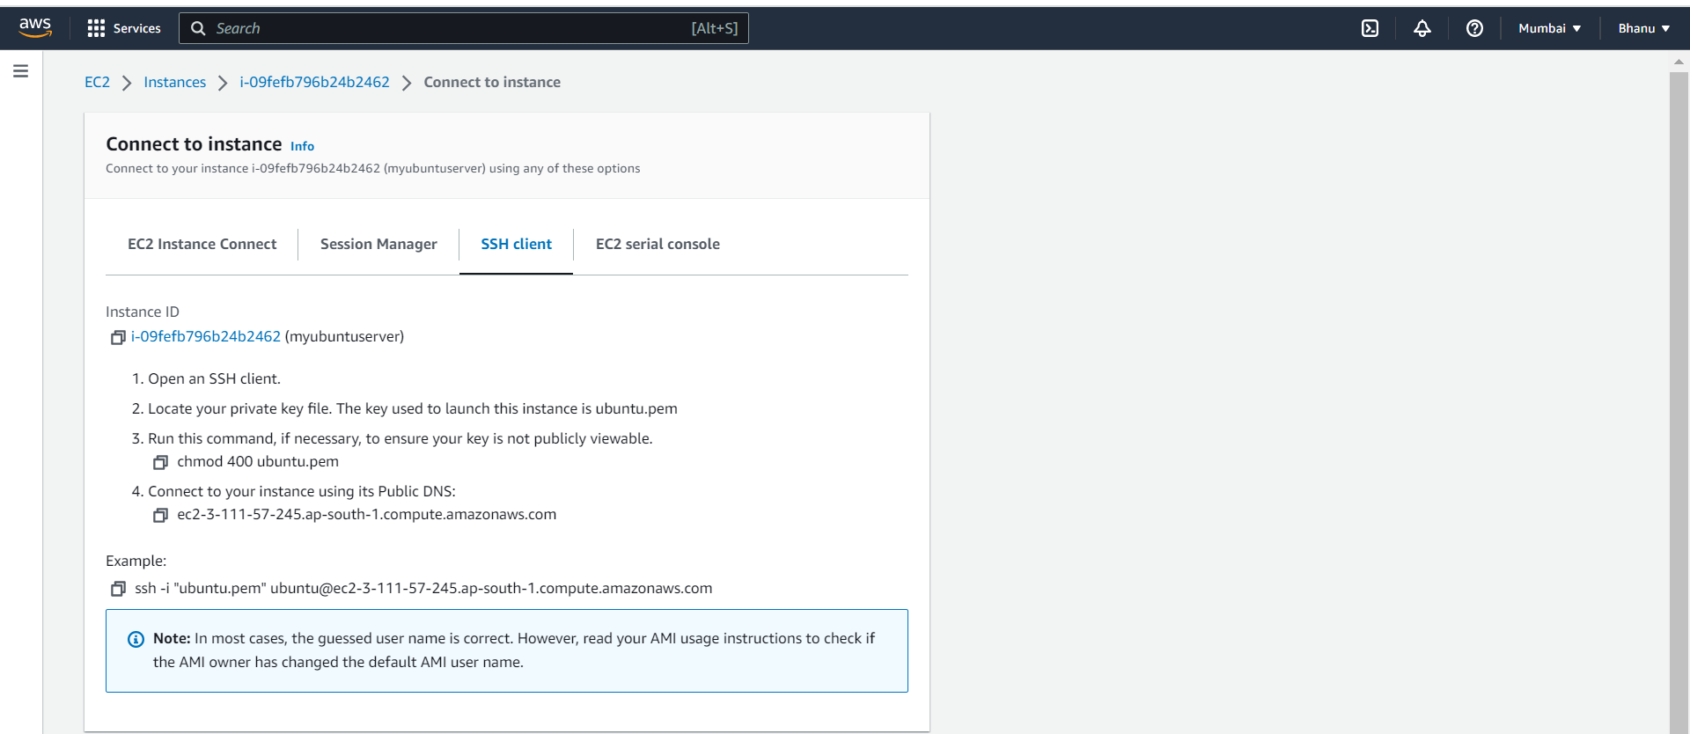

Step 12:Open the git bash and locate to the folder where you have the keypair downloaded .

Then give the ssh command to connect to the instance.

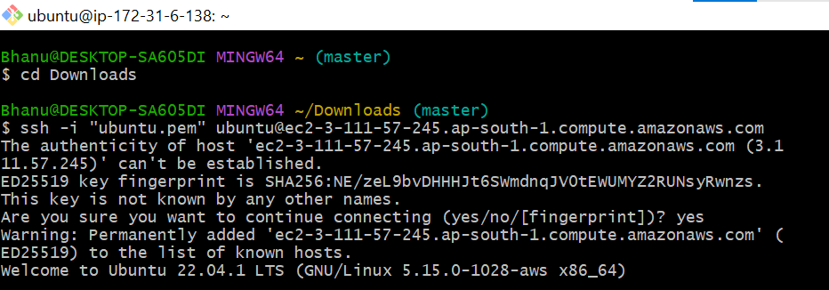

Step13:

Now we are successfully connected to the instance.

Give **t**he **sudo apt update** command for all the updations to be made.

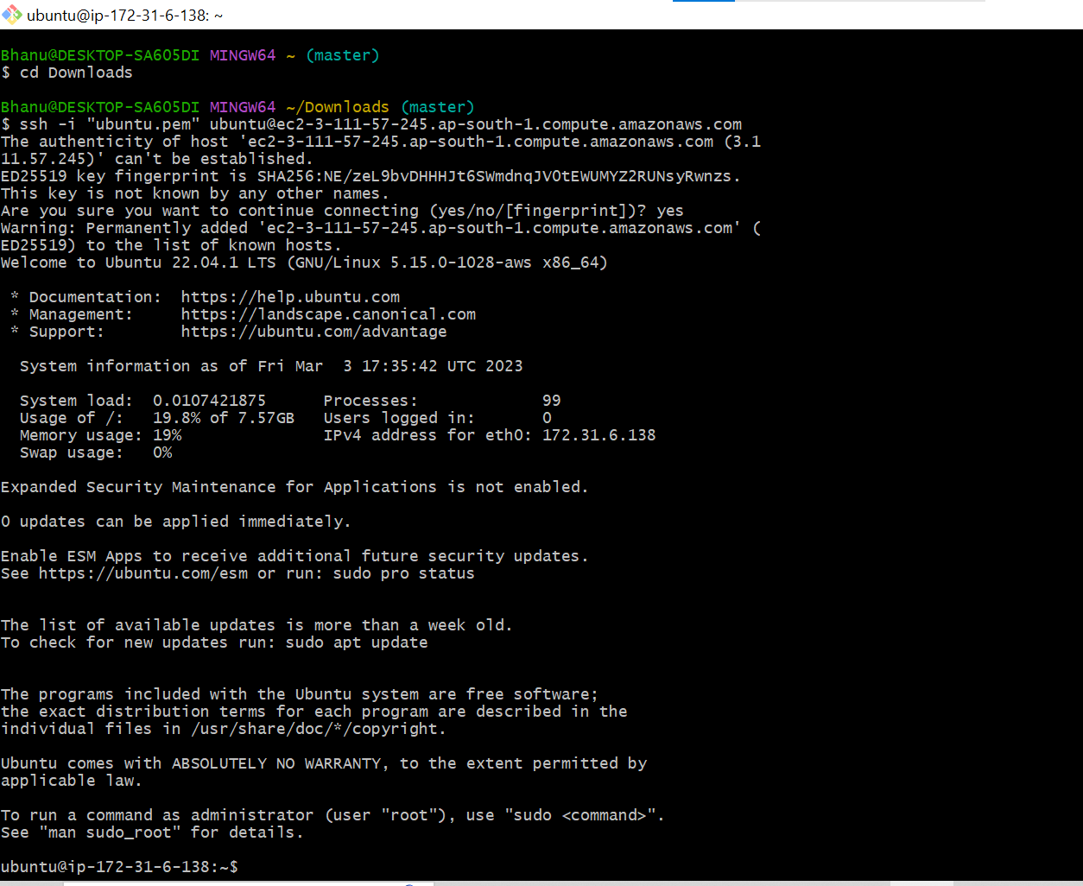

Step 14:

To update use the below command

sudo apt update

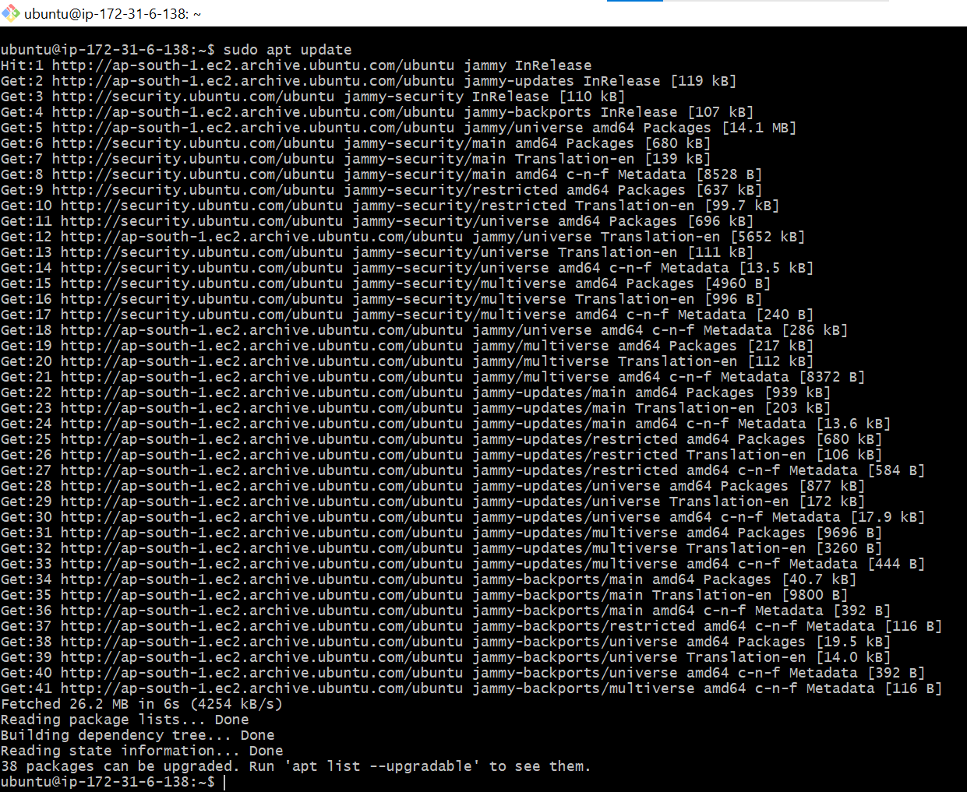

Step 15:

To install the node js the command is

**sudo apt install nodejs**

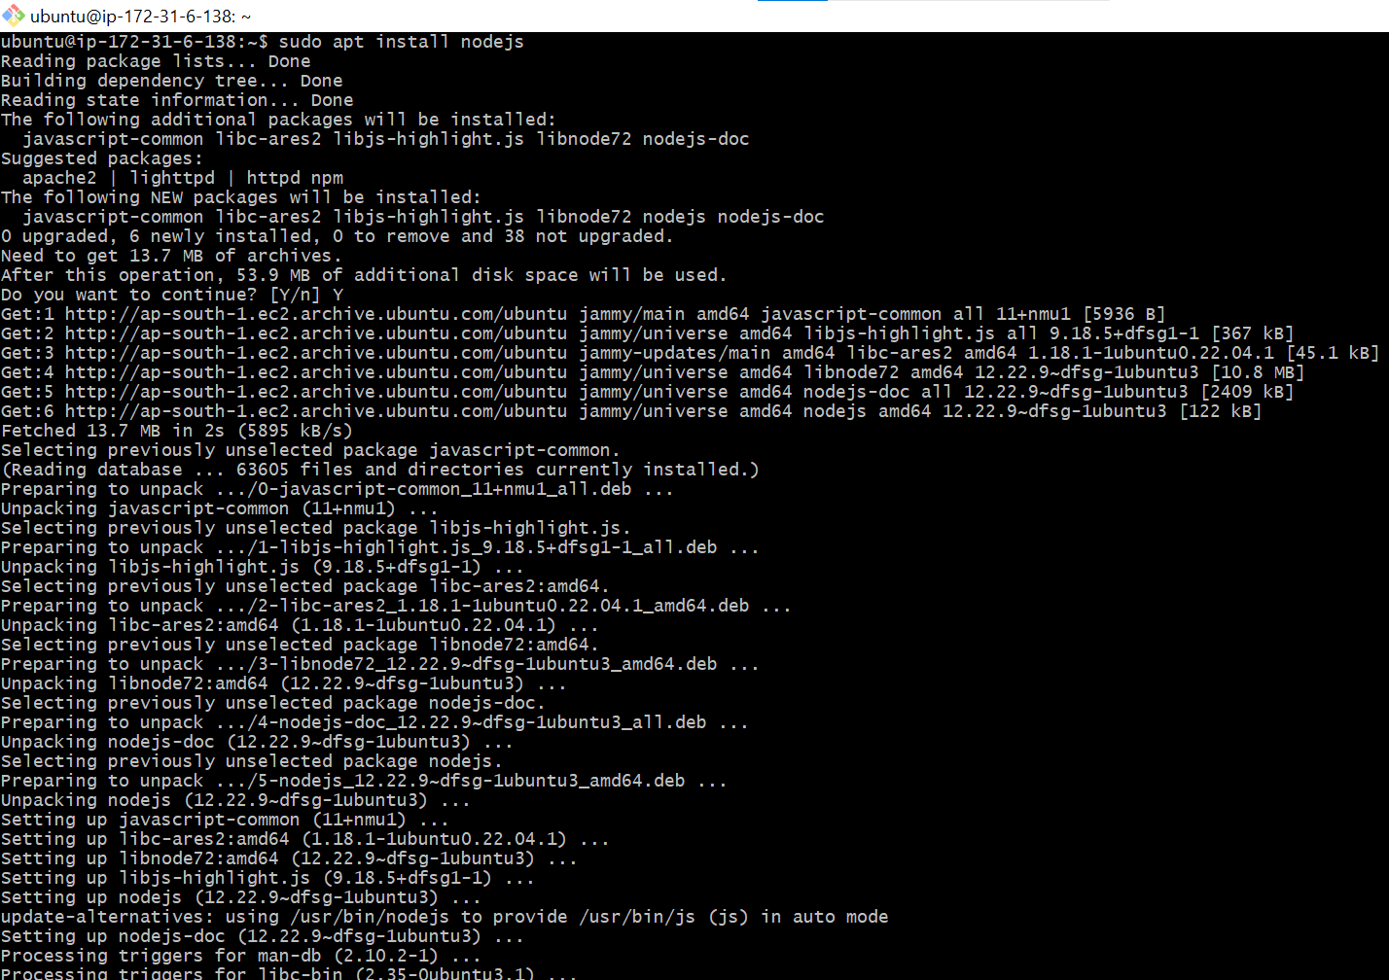

Step 16:

The node js is now installed,to check the version of node js use the command,

**node --version**

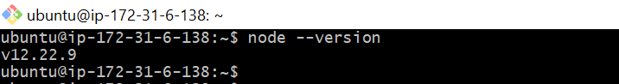

**Configuring elastic ip address:**

**Step1:In the network and security panel,choose the elastic ips**

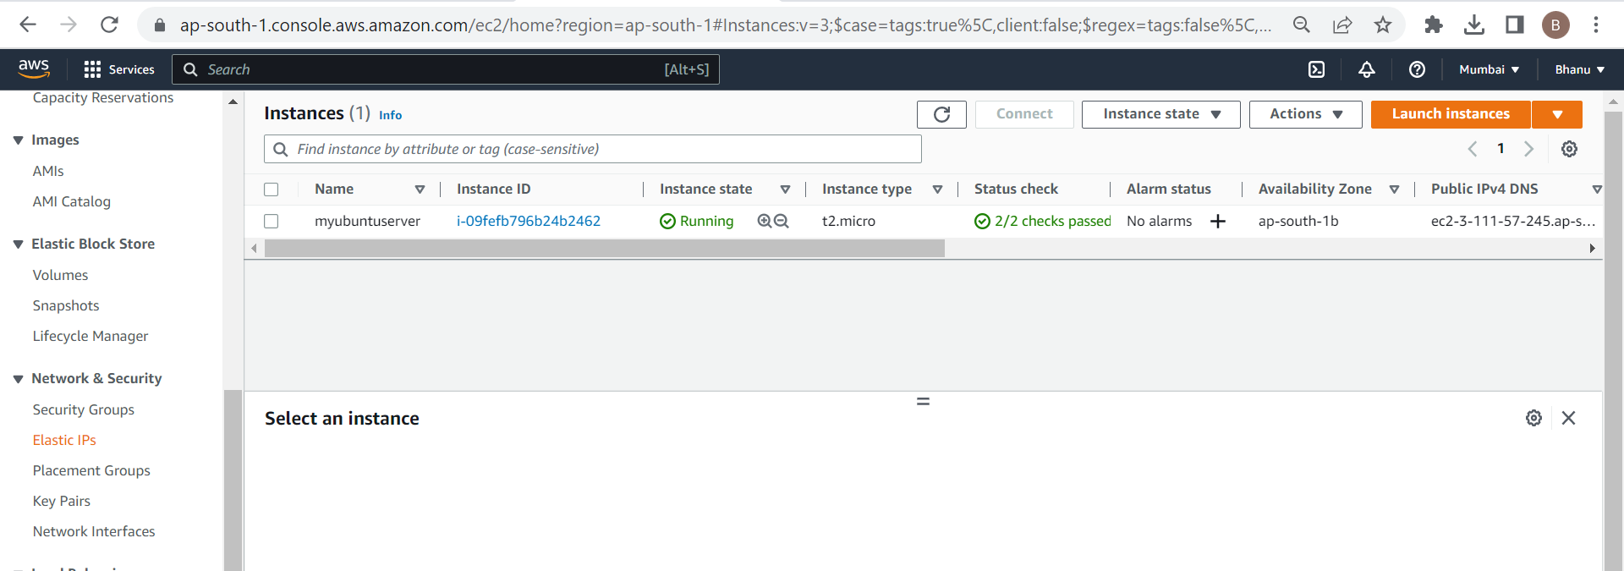

**Step 2**: Choose allocate elastic ip address

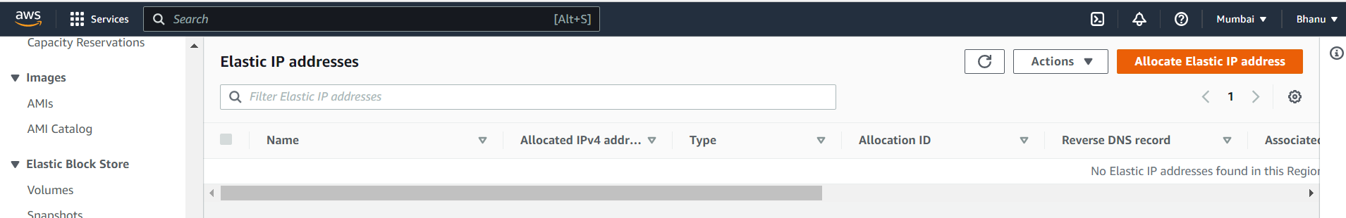

Step3:

Select the network border group or you can also leave it as default.

Select the amazon’s pool of IPv4 address.

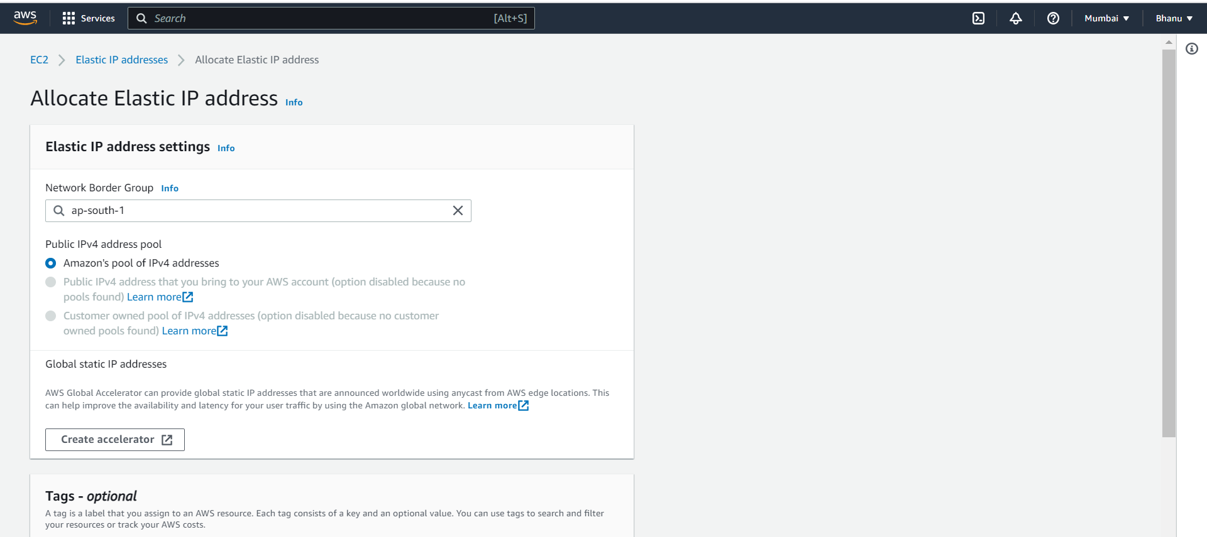

Tags are optional ,you can give it as key value,

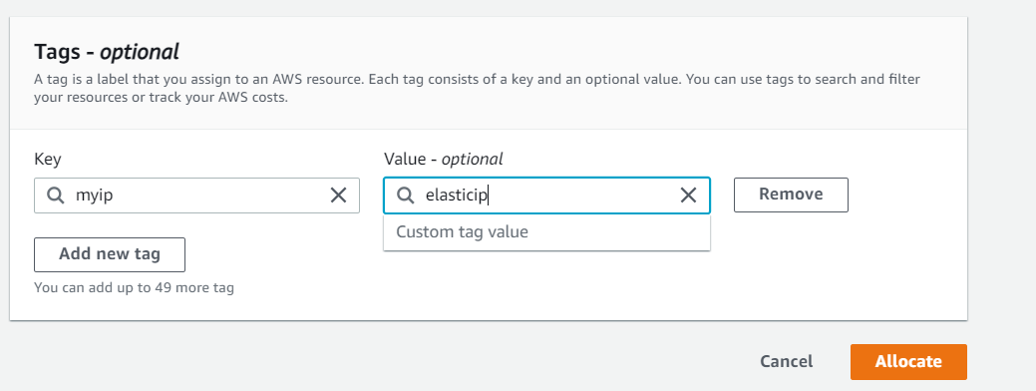

Step 4: Click on allocate.

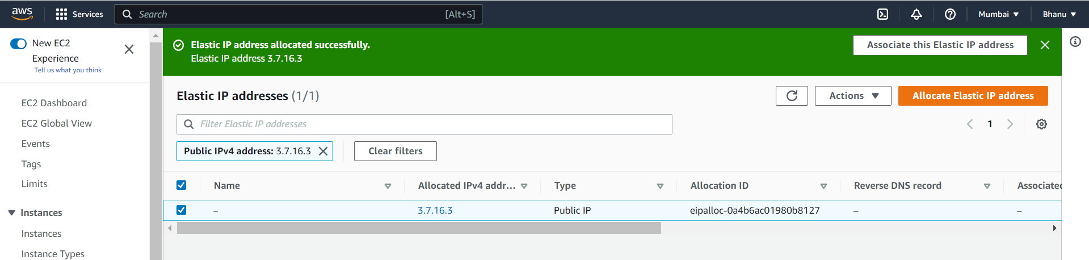

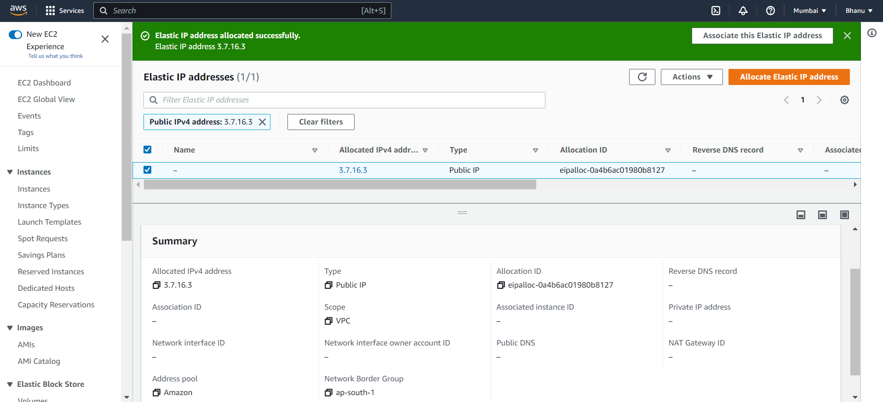

**You can view the summary by selecting the elastic ip.

**Step5: Select the elastic ip and choose actions,under actions select the associate elastic ip address.**

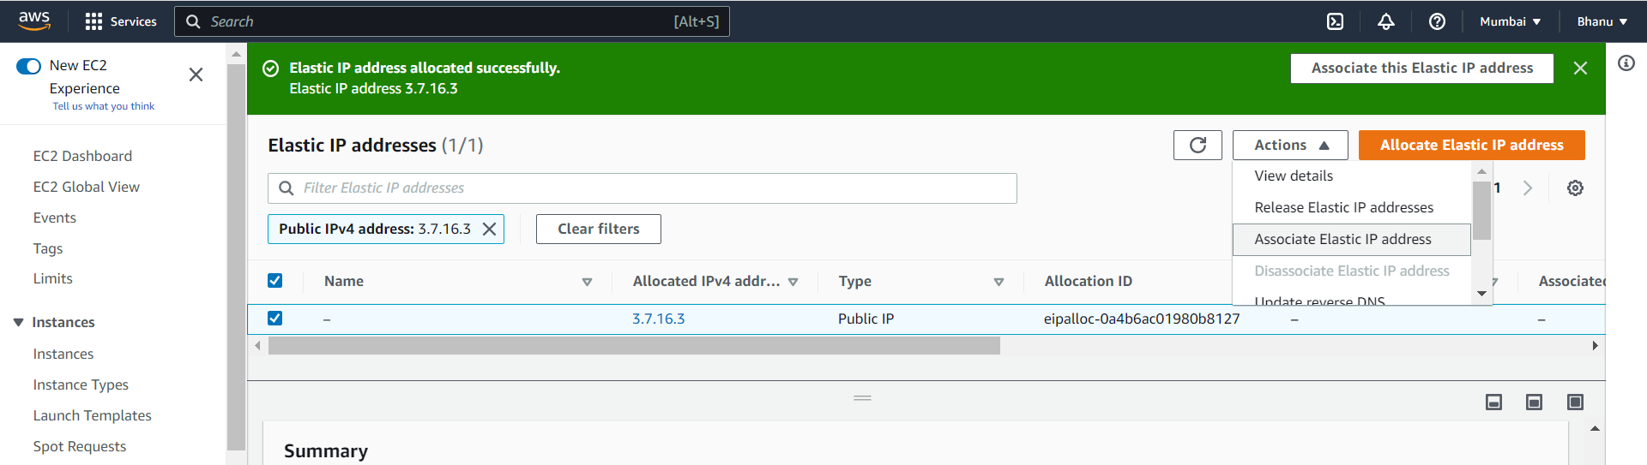

**Step 6:To associate the elastic ip to an instance select the resource type as instance.**

**By default it gives the private ip address of the instance.**

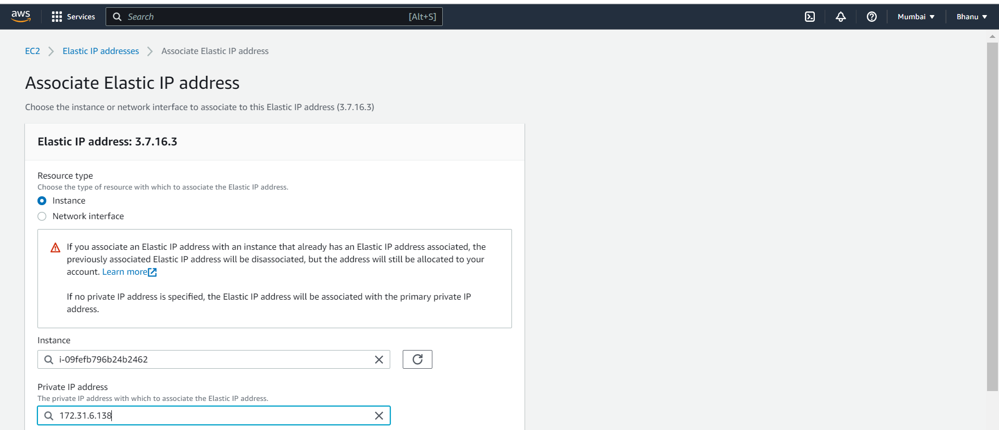

Step7:click on associate.

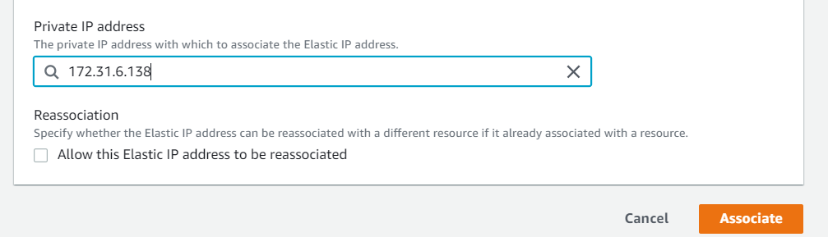

**Now the Elastic ip address is successfully associated to the instance

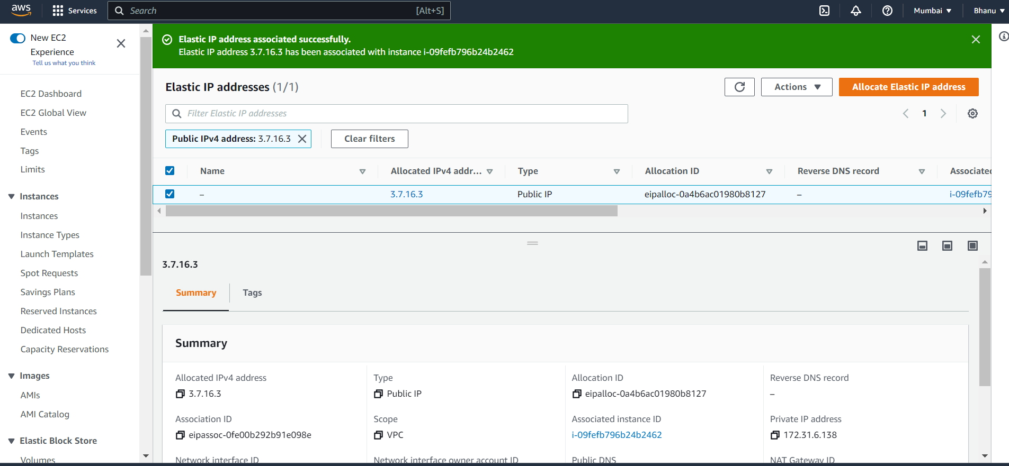

Step 8:Select the elastic ip to view the summary,in the summary it shows the instance id to which it has been associated.

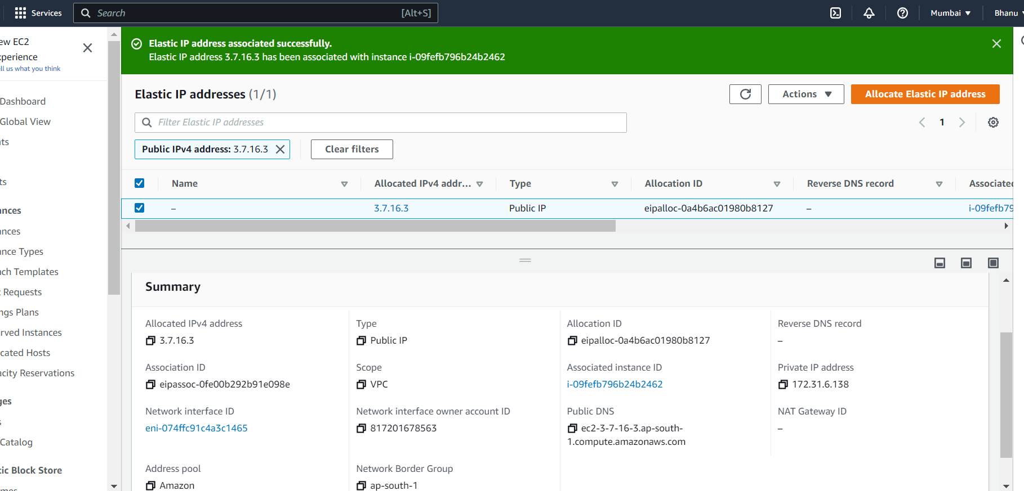

Step 9:Go to instances and select the instance,you can see that the elastic ip would appear there.

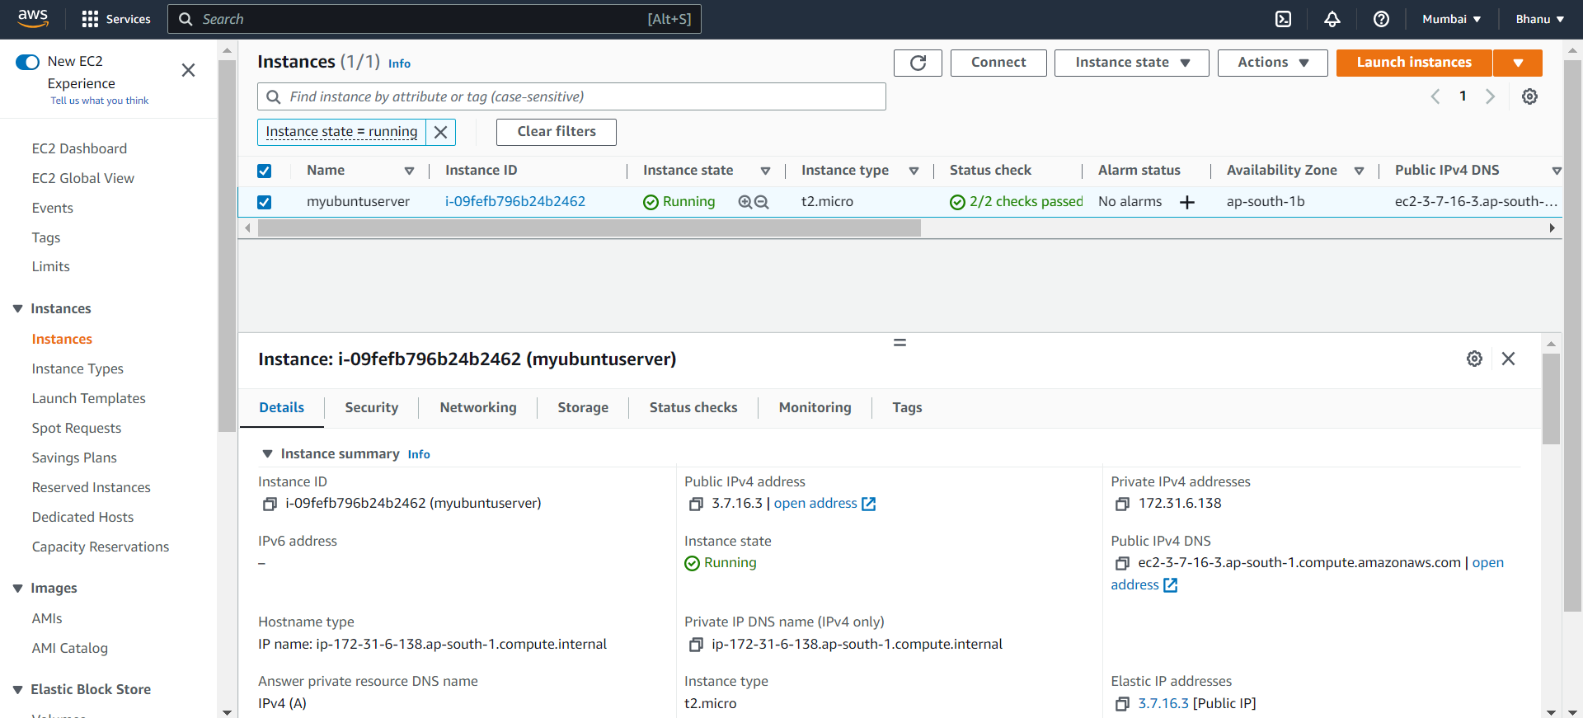

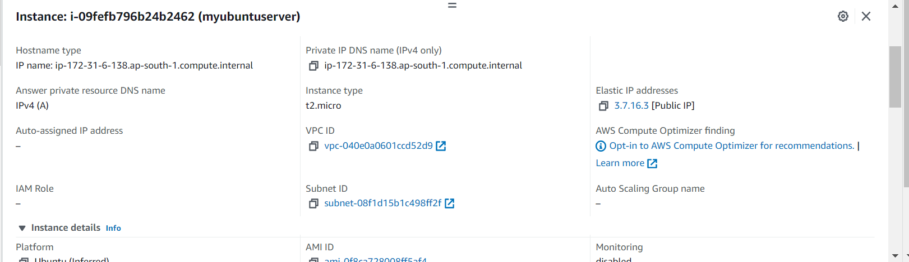

An Elastic IP address is a static public IPv4 address associated with your AWS account in a specific Region. Unlike an auto-assigned public IP address, an Elastic IP address is preserved after you stop and start your instance in a virtual private cloud (VPC).

**Create an S3 bucket and upload an object to it and show the object URL for reference.**

**Step1:In the services ,go to S3.the following page appears,click on create bucket.**

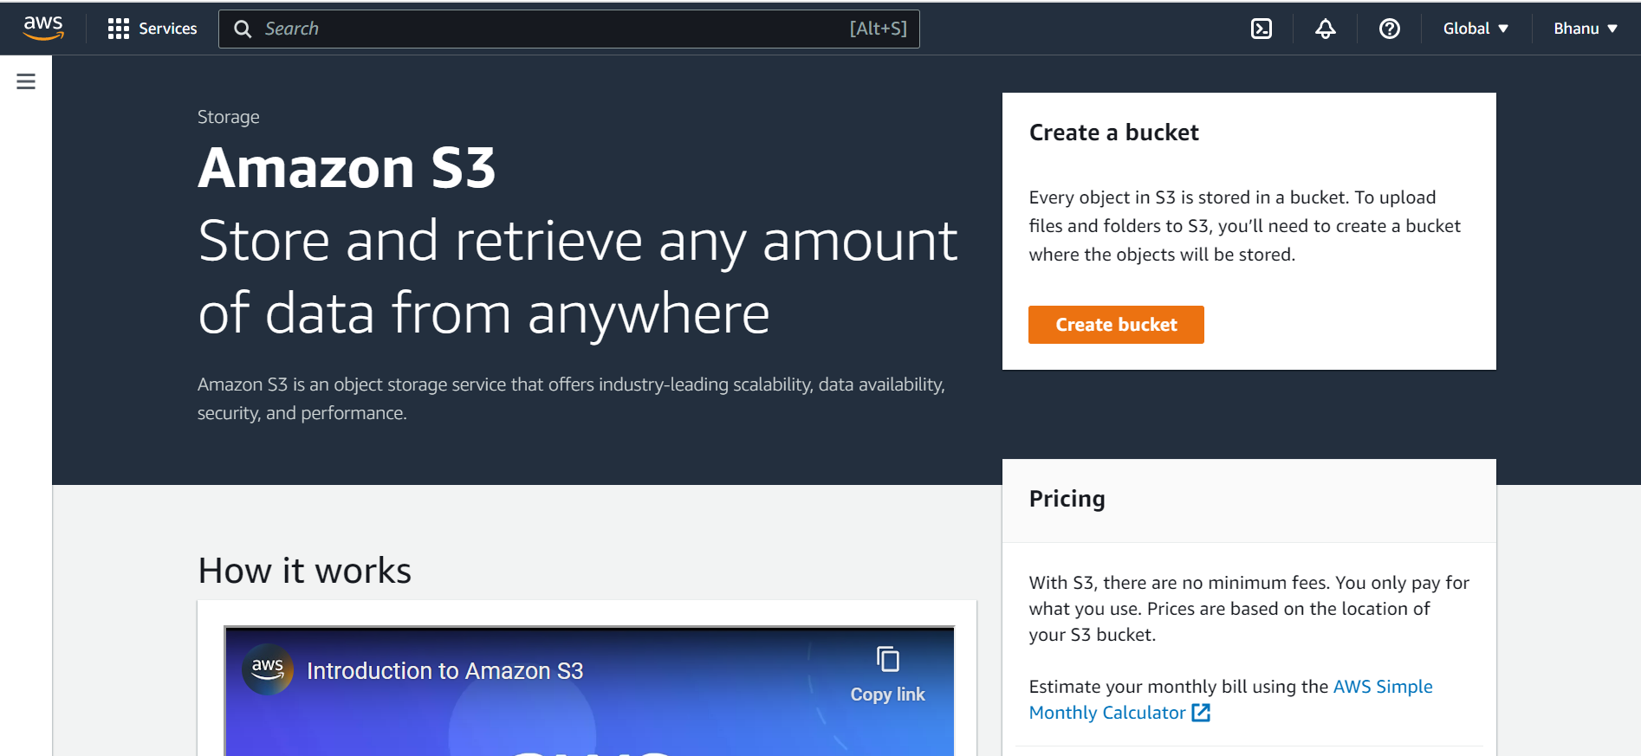

**Step 2:Give the bucket name and select the aws region in which to create the bucket.**

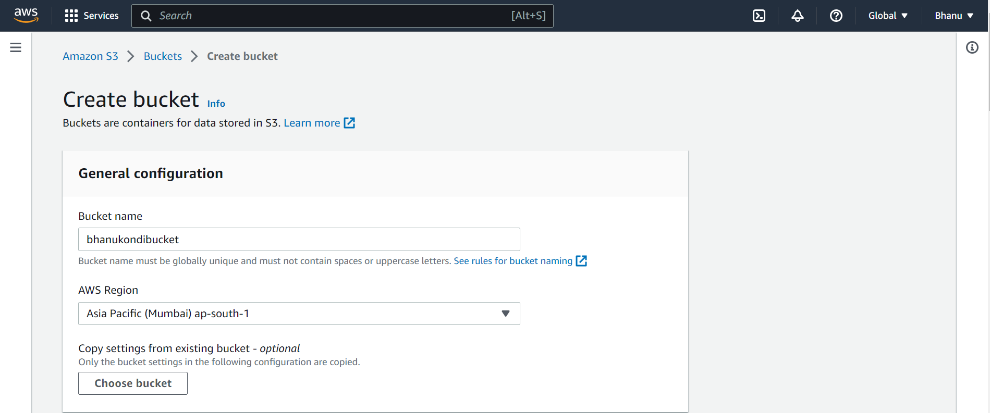

**Step 3:Select the option ACLs diabled under the Object ownership.**

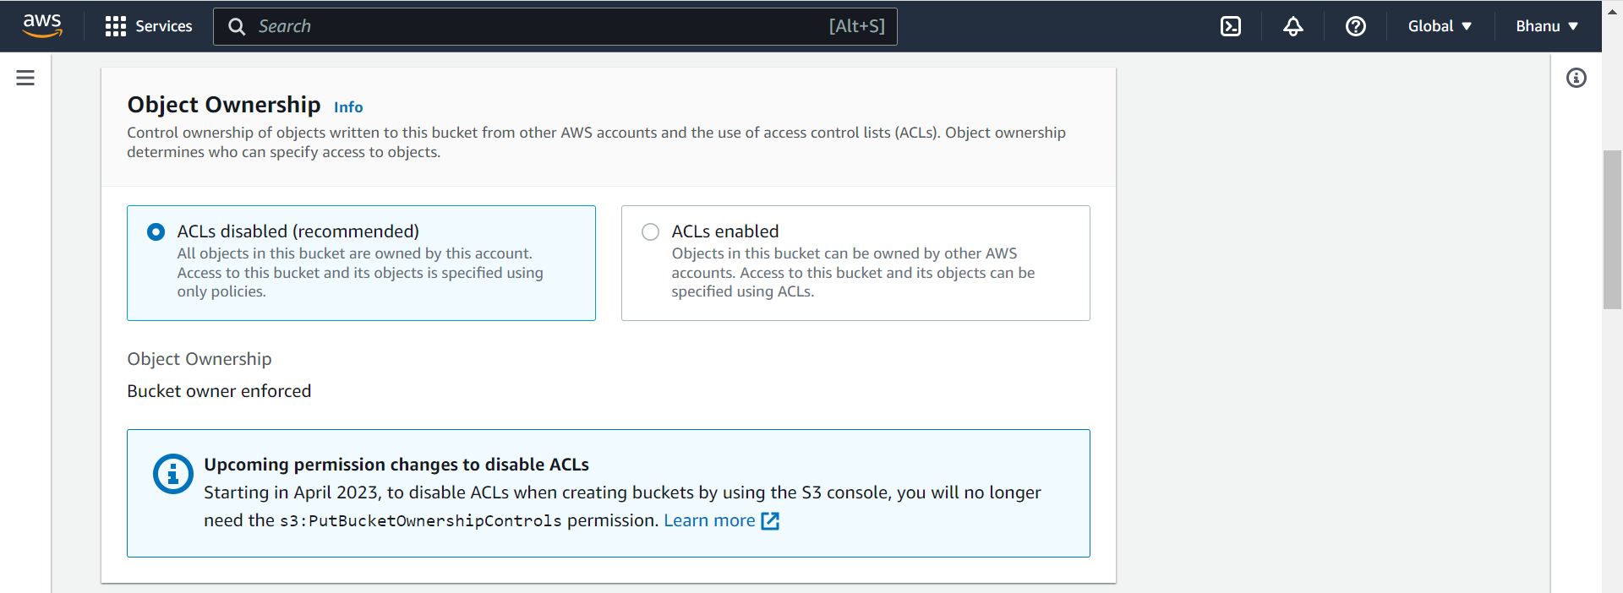

**Step 4:Uncheck the block all public access for the bucket.**

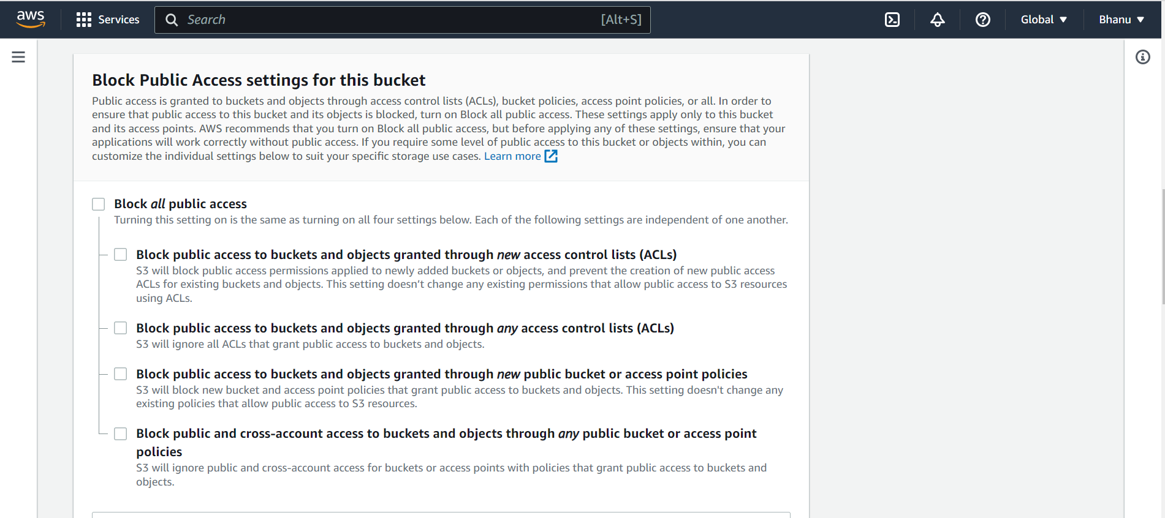

**\*\*Check the acknowledgment box.**

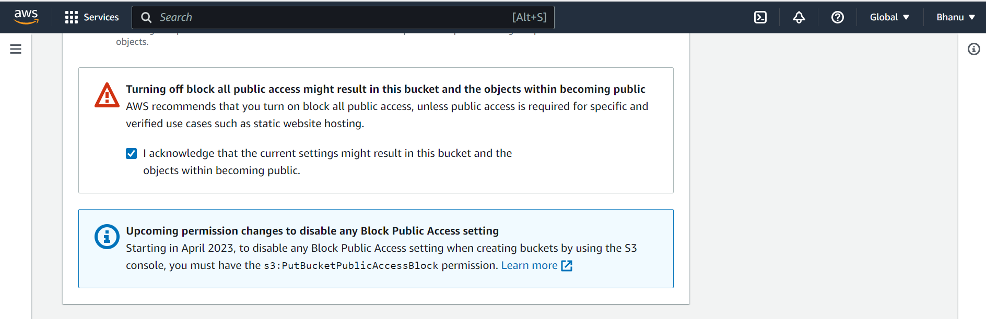

**Step 5:Enable the bucket versioning. To keep the multiple variants of an object in same bucket.**

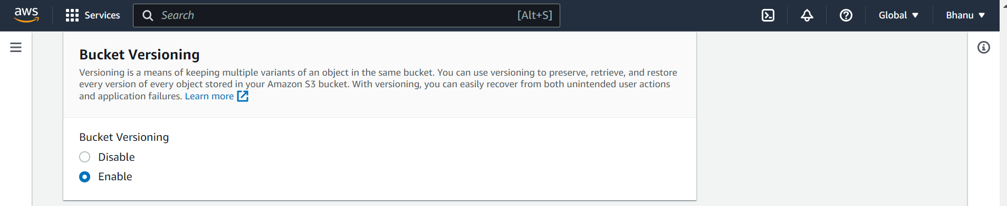

**Step 6:You can give tags if needed.it is optional.**

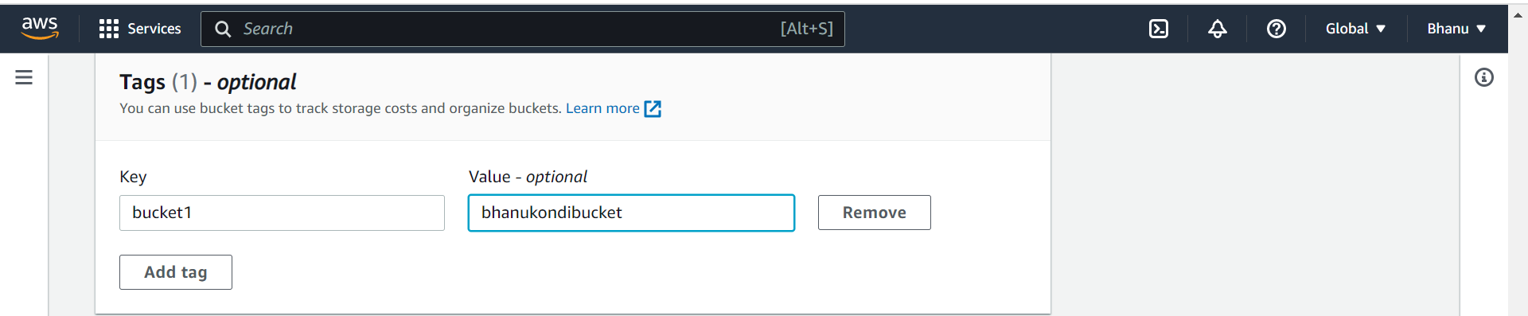

**Step 7:The default encryption is Amazon S3 managed keys and enable the bucket key.**

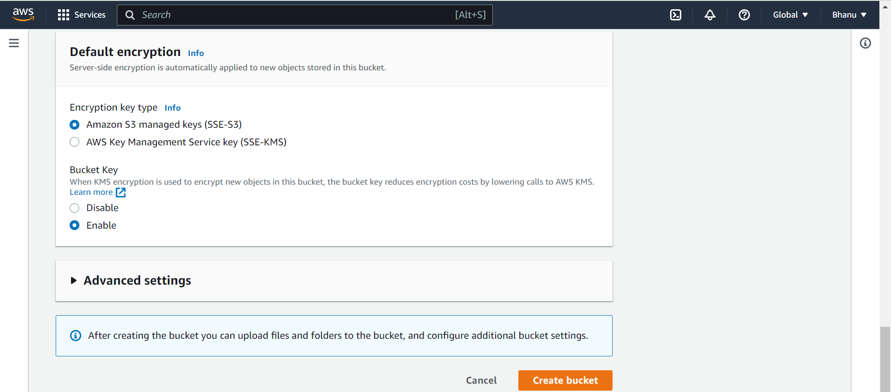

**Click on create bucket**

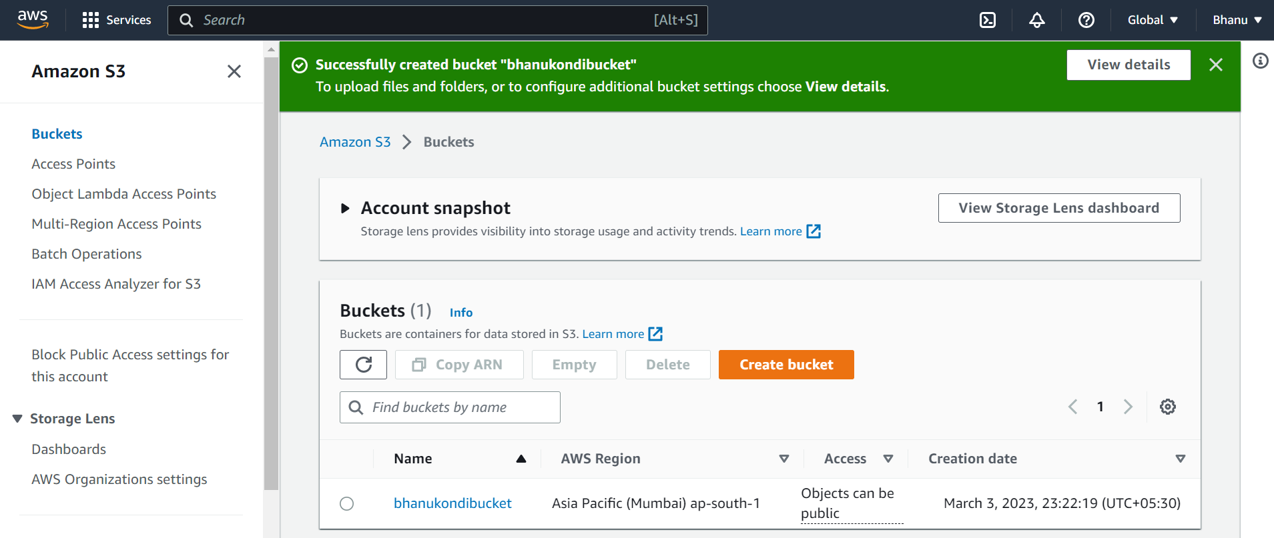

**Step 8:The bucket is created successfully.you can upload the objects by clicking on upload.**

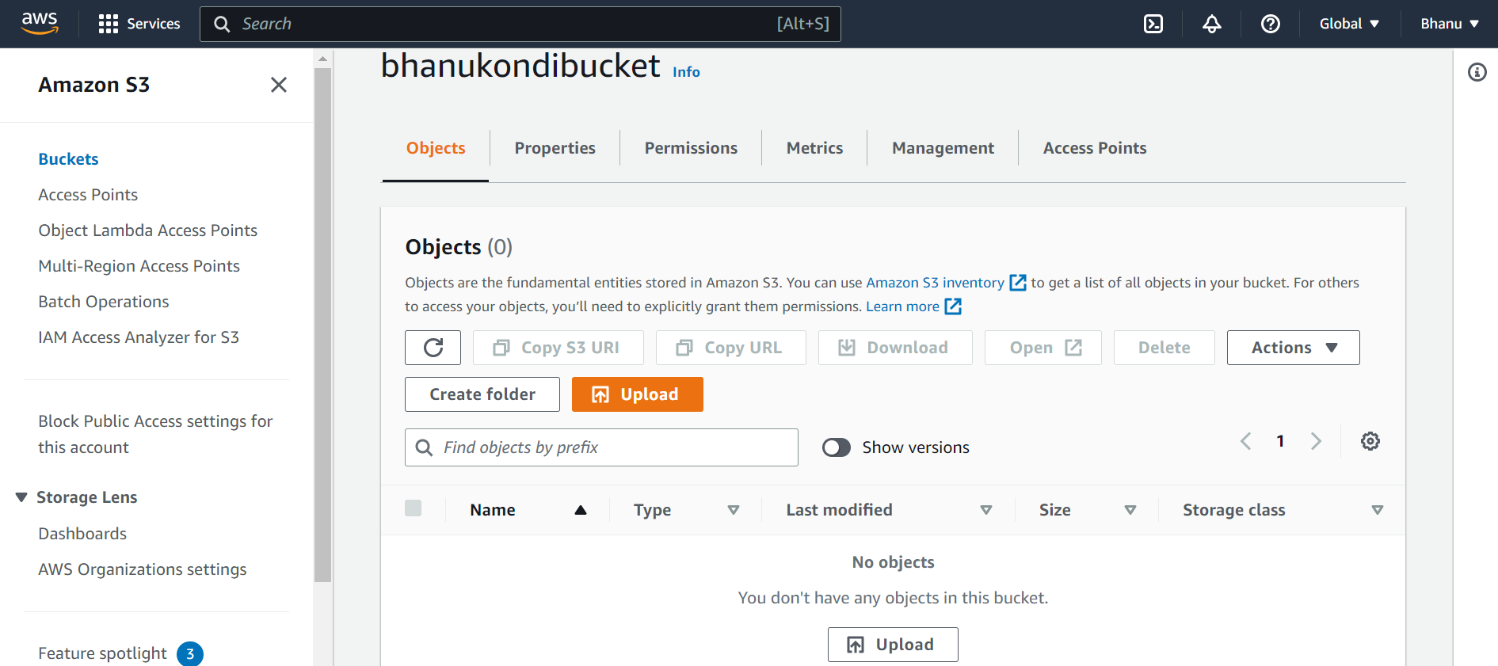

**Step 9: Click on add files to add the files,and to add folders click on add folder.**

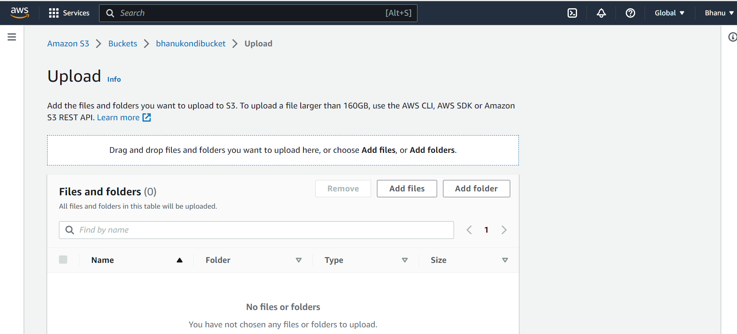

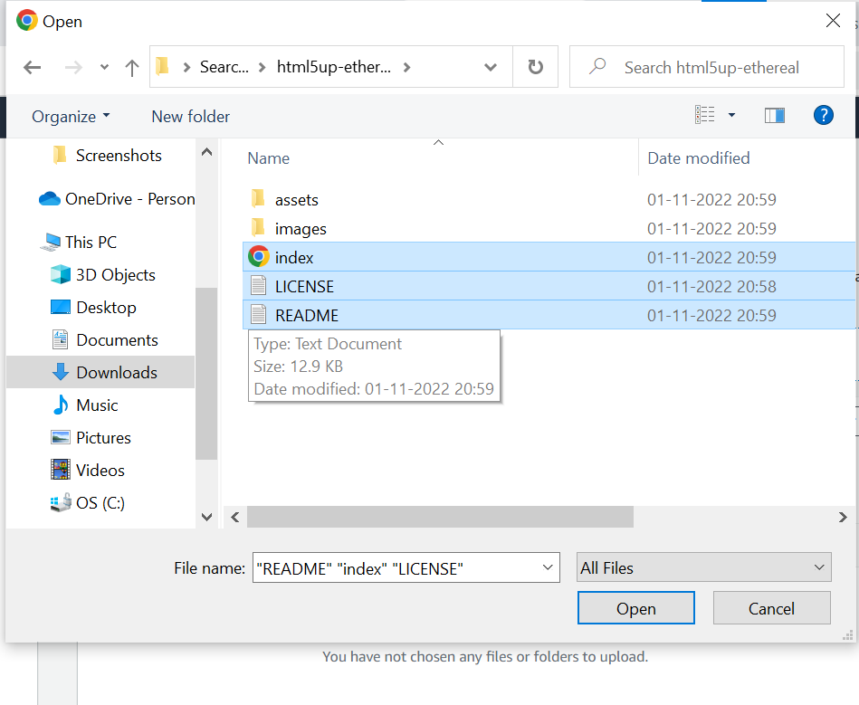

**Step 10:Now we have added files and folder (objects) in the bucket.**

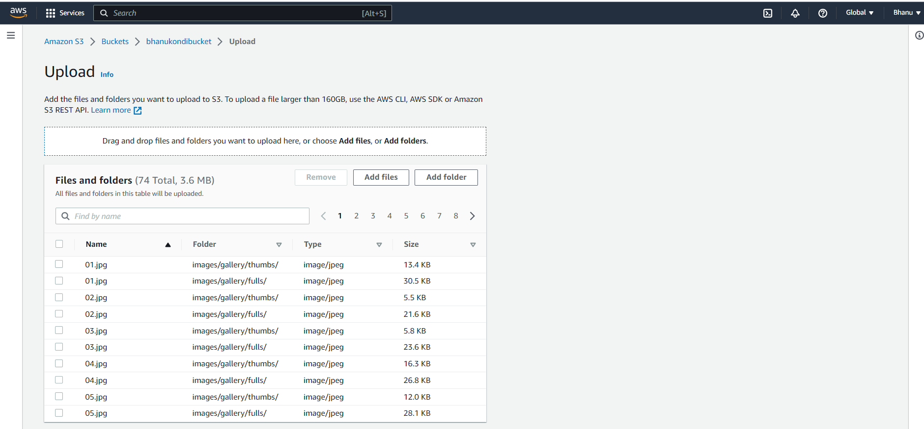

**Step 11:Click on upload.**

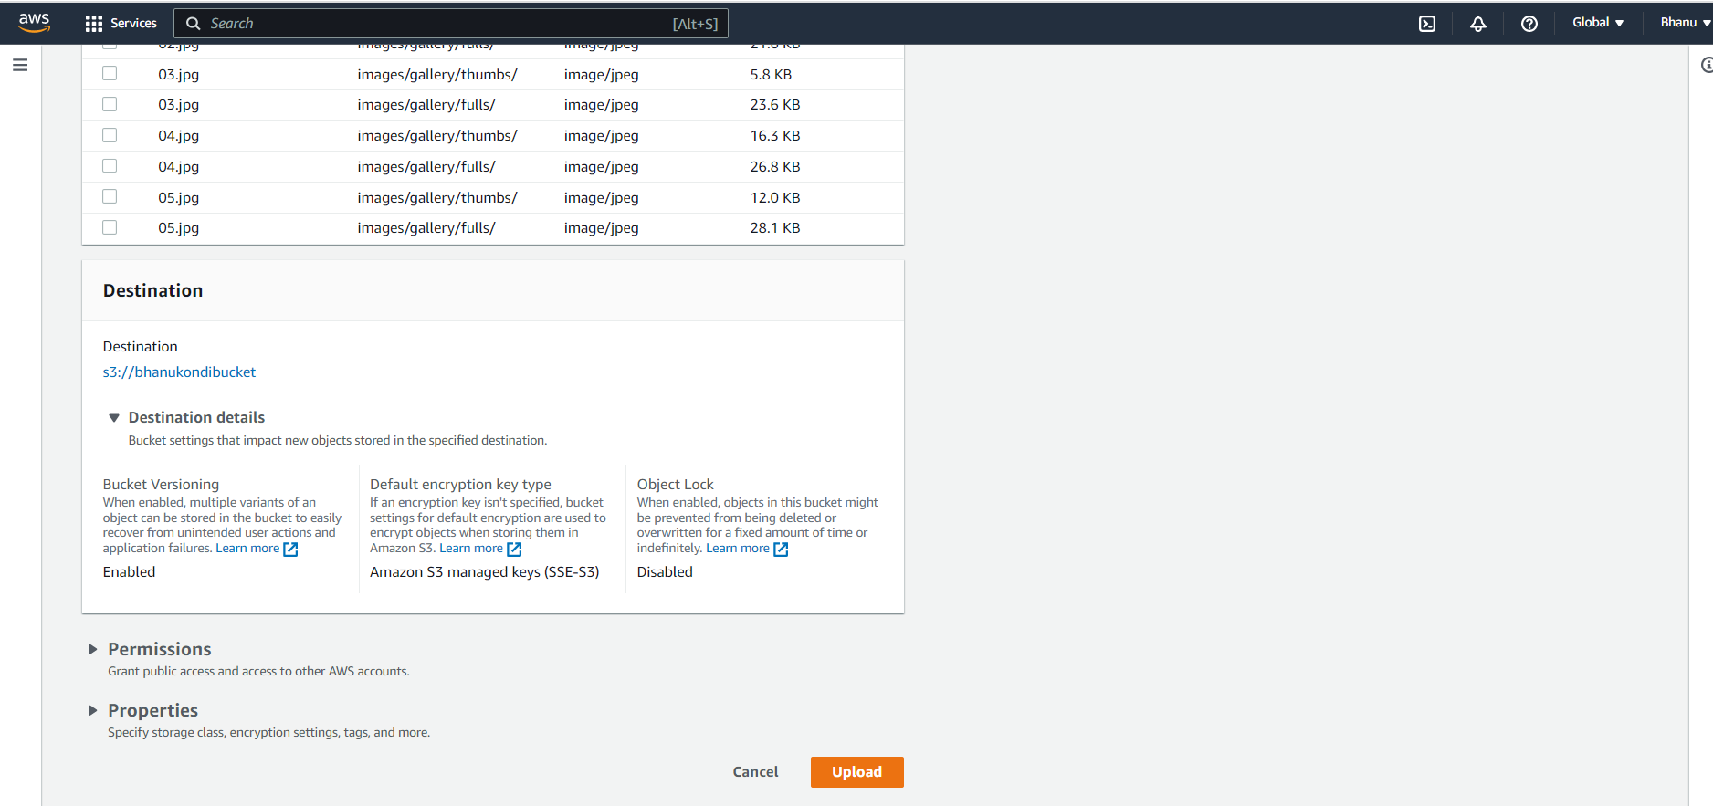

**Step 12:Now the objects are uploaded to the bucket.**

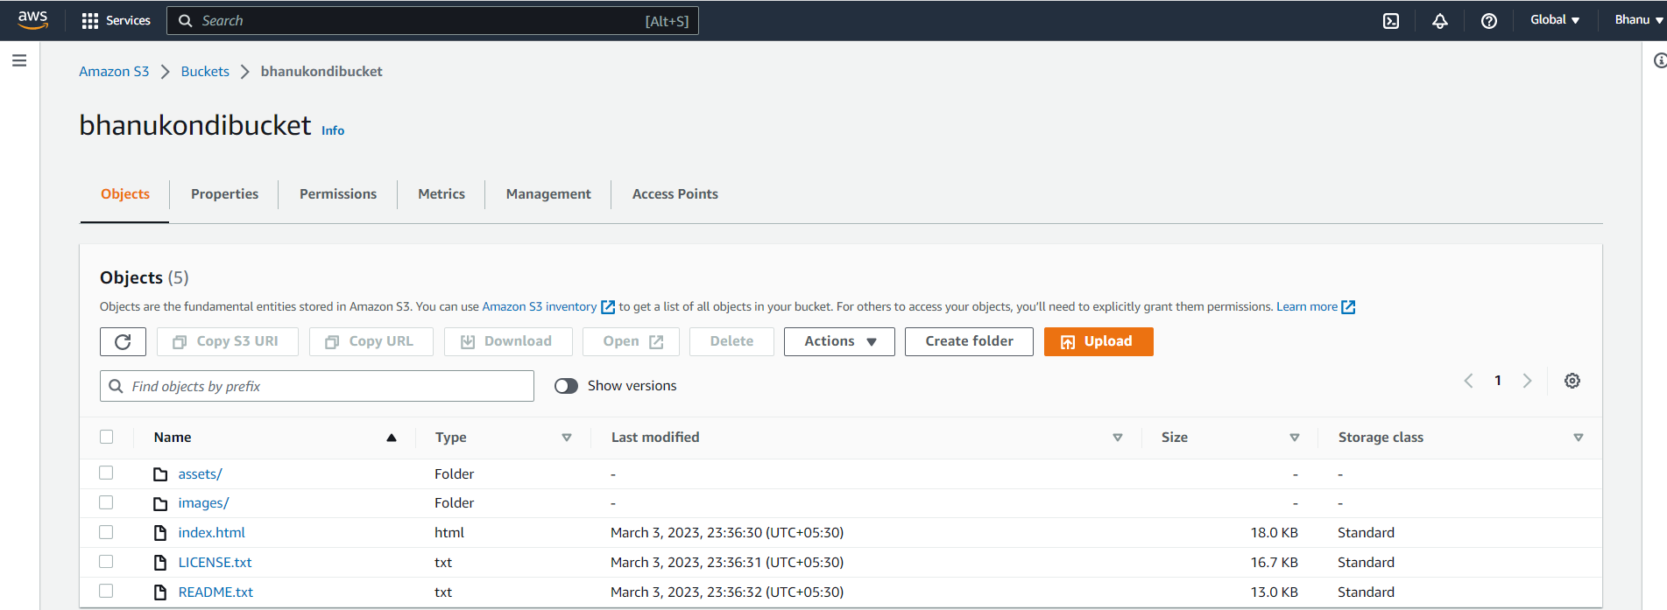

**Step 13:Go to properties and go to the static website hosting.**

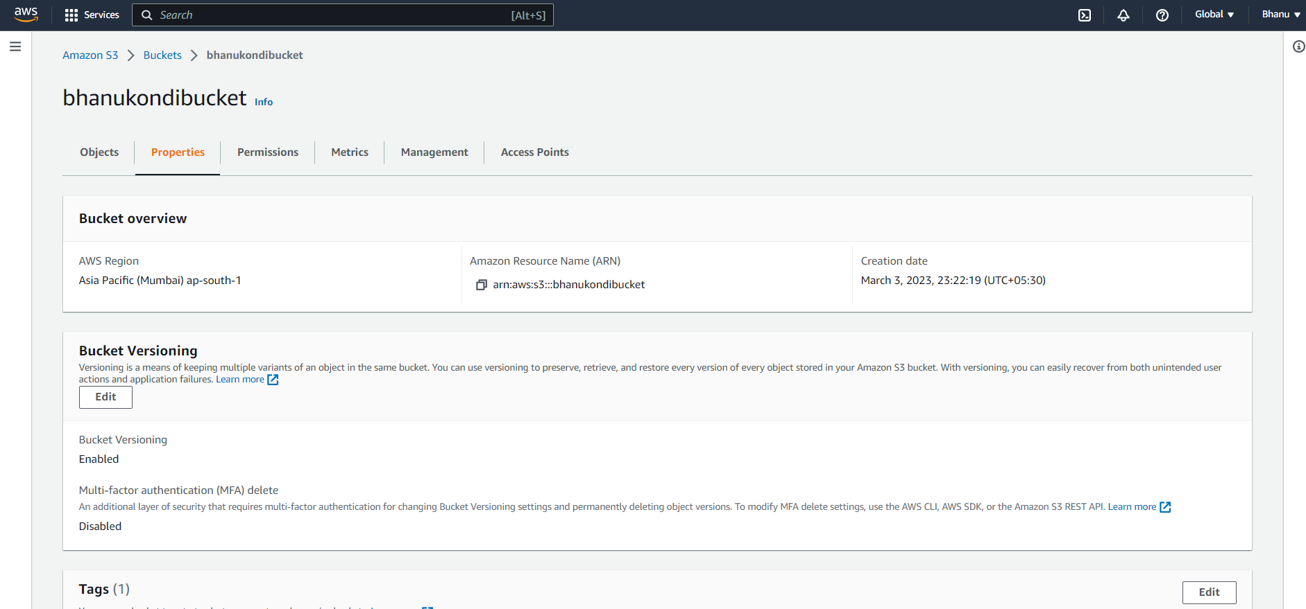

**Step 14:click on edit and enable the static website hosting and give the name of the main document.**

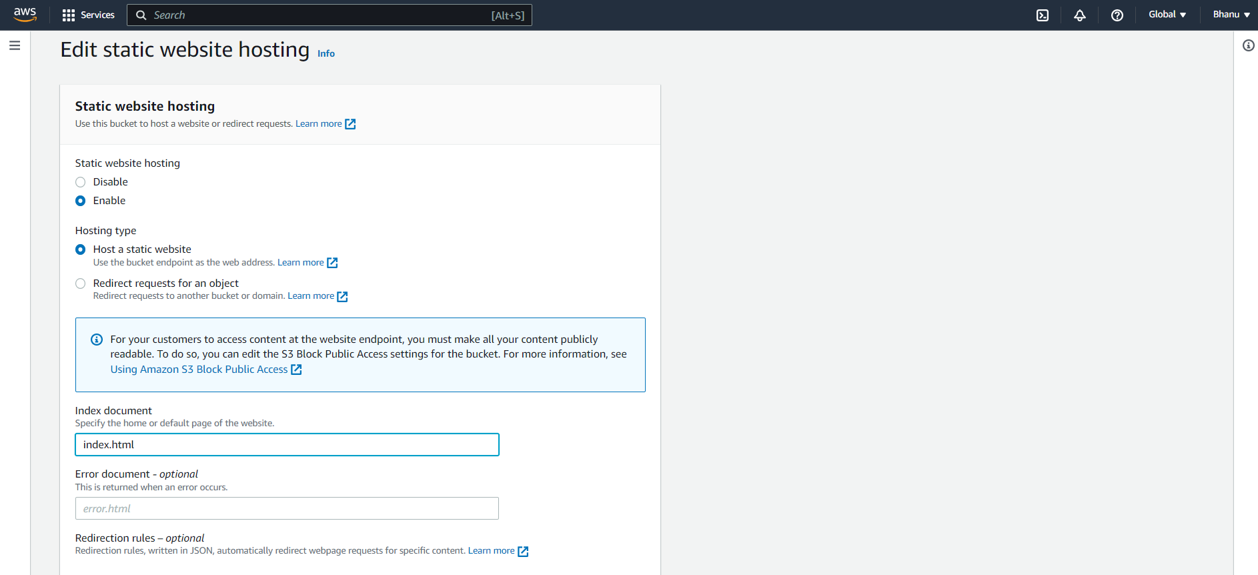

**Step 15:Go to permission tab and edit the bucket policy with the predefined template ,so now the bucket is publicly accessible.**

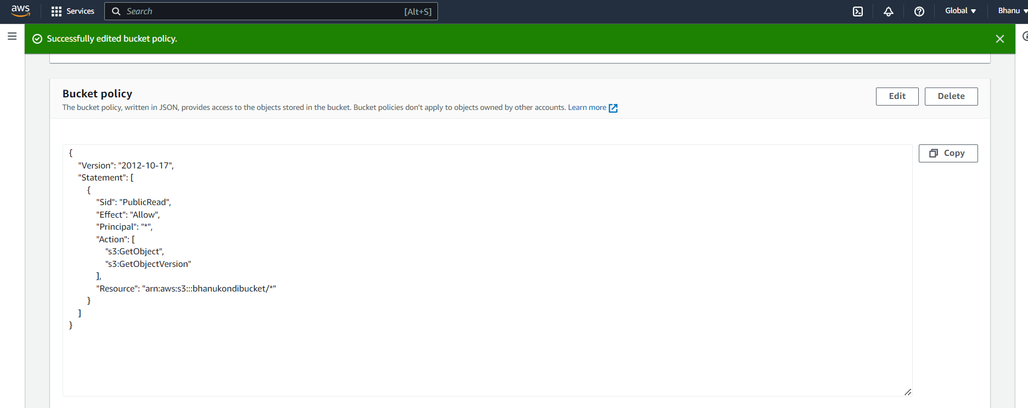

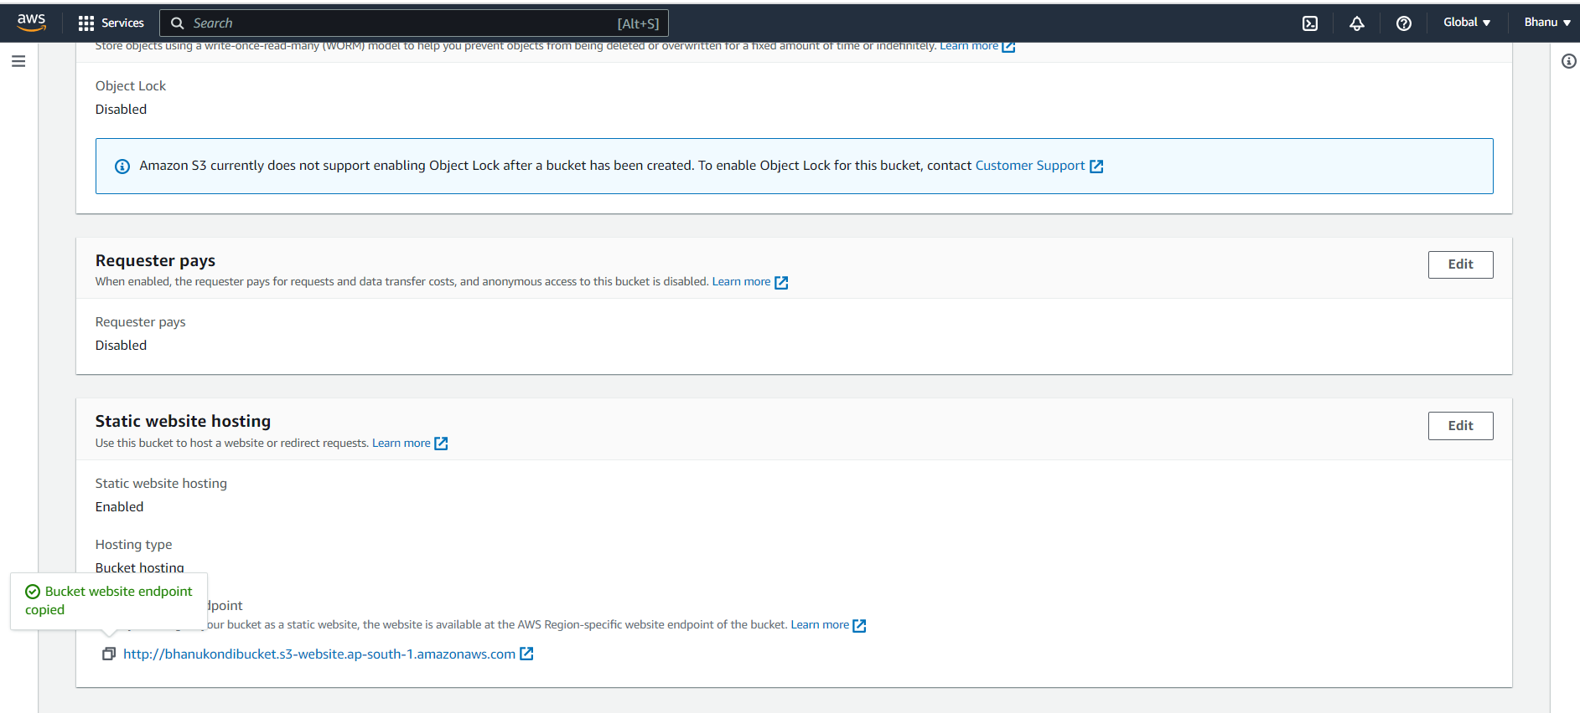

**Step 16:Go to the static website hosting under properties and copy the link and paste it in browser.**

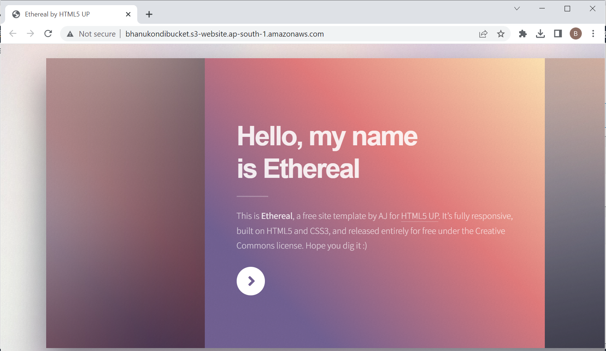

**Step 17:Go to the bucket and select any object click on copy URL for the object refernce URL and open it in browser.**

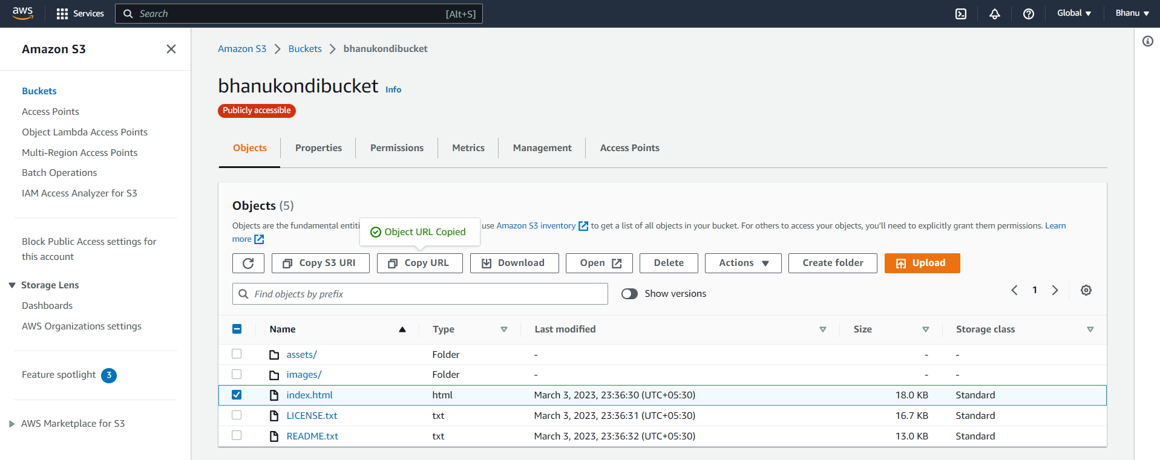

**Step 18:The following page appears.**

**The object reference url is**

[**https://bhanukondibucket.s3.ap-south-1.amazonaws.com/index.html**](https://bhanukondibucket.s3.ap-south-1.amazonaws.com/index.html)

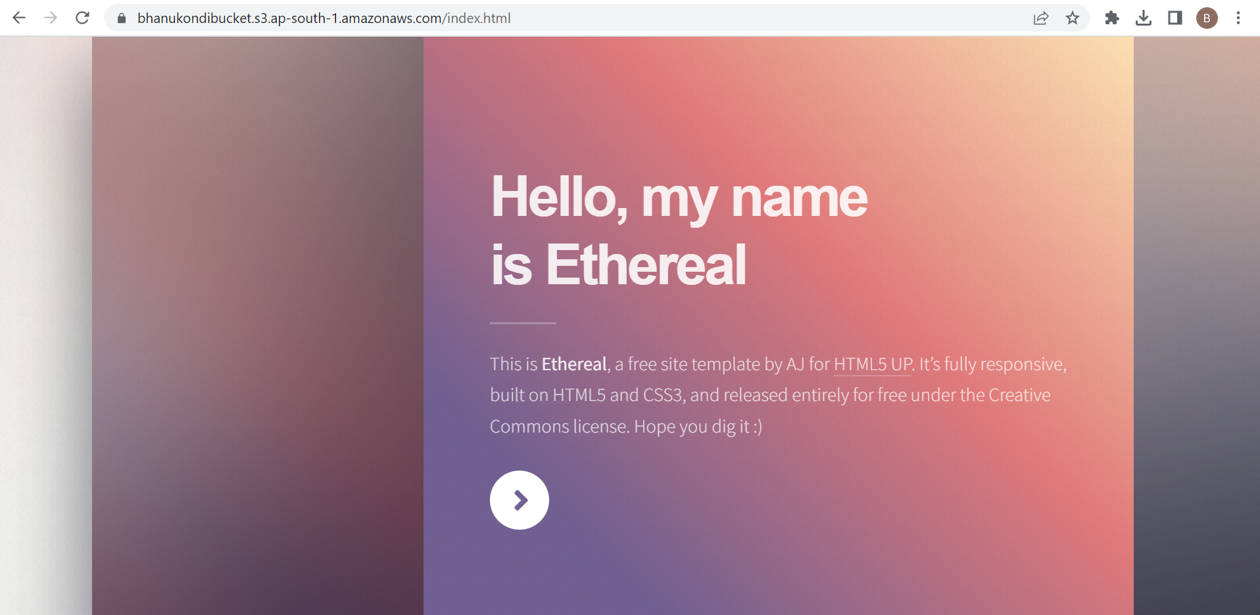

**Step 19:Open bucket and upload another object.**

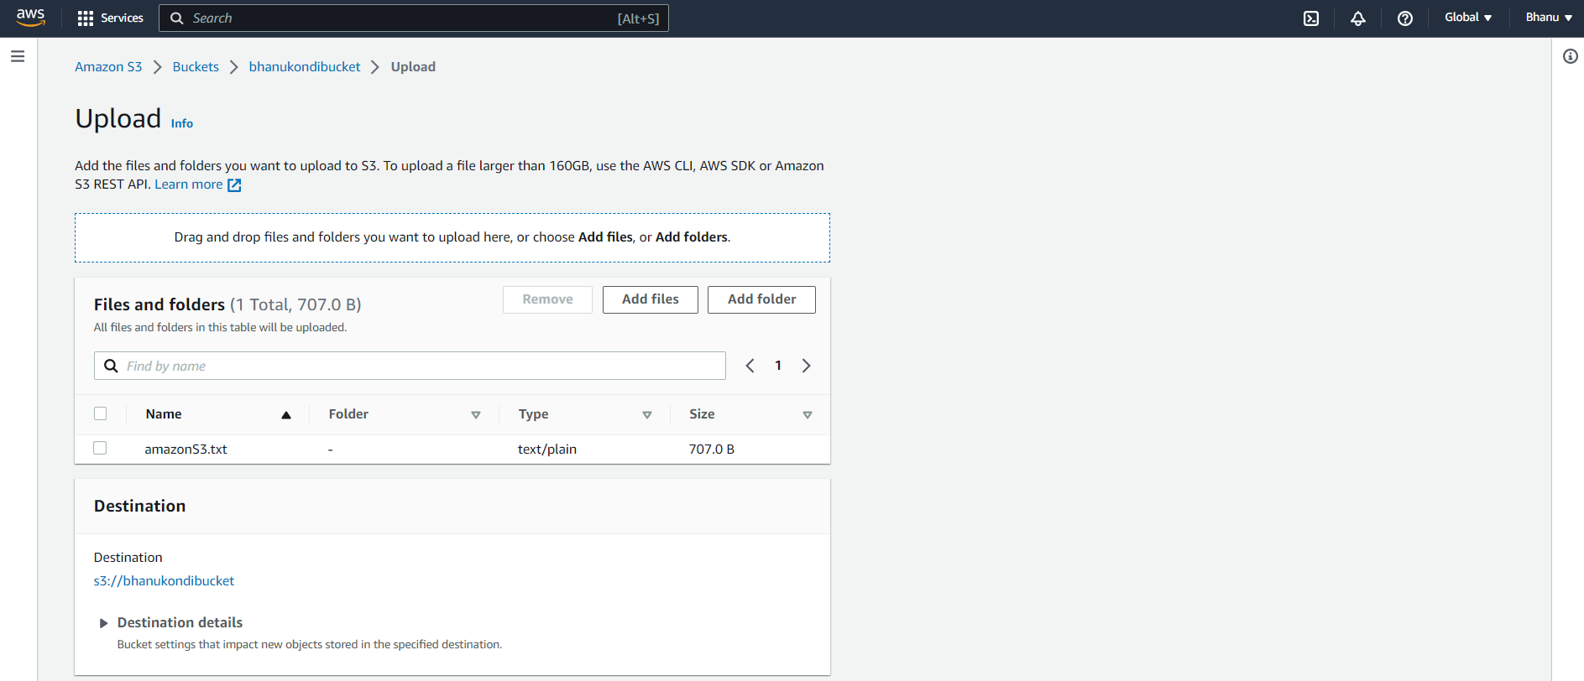

**\*\*Click on upload.**

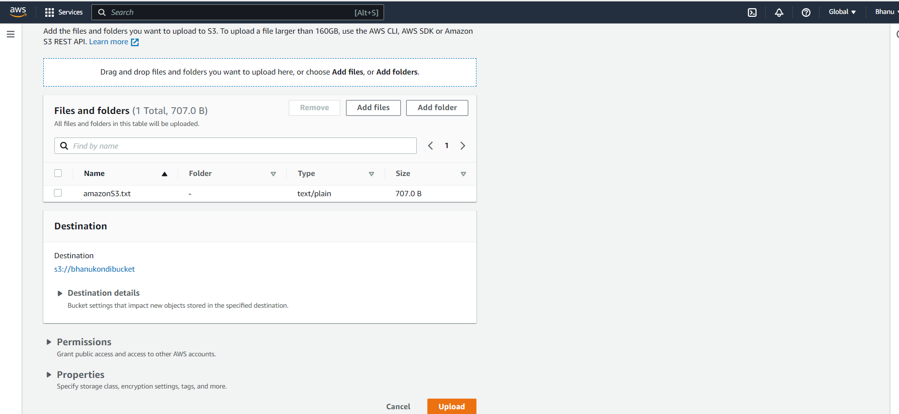

**\*\*The file is uploaded successfully and click on close.**

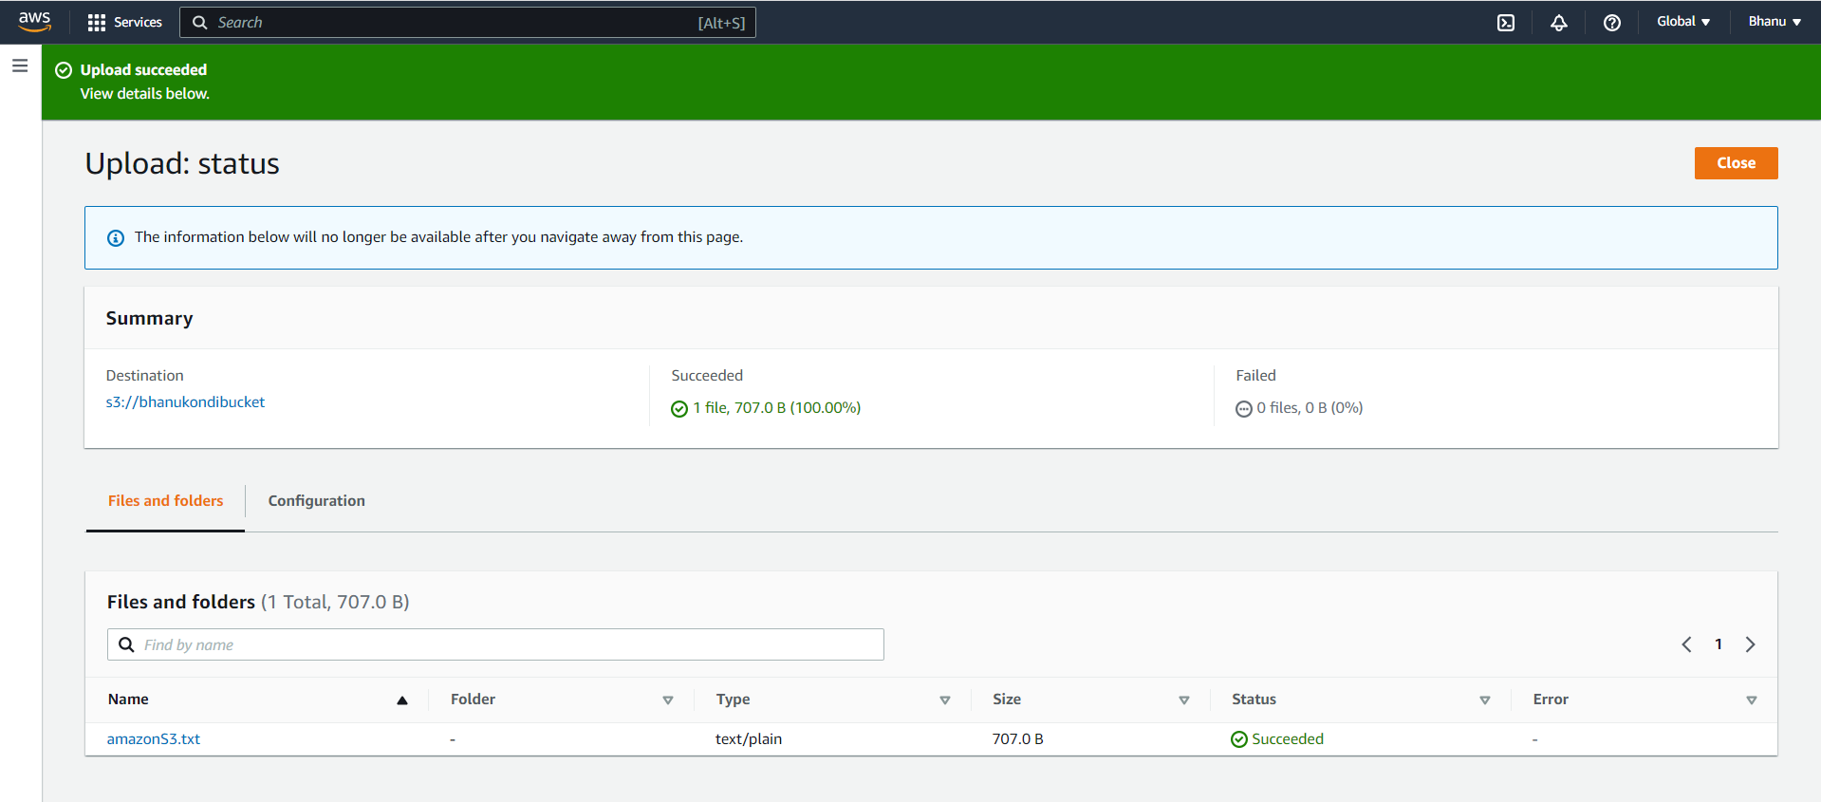

**Step 20:Go to the bucket and select the object that is uploaded now.**

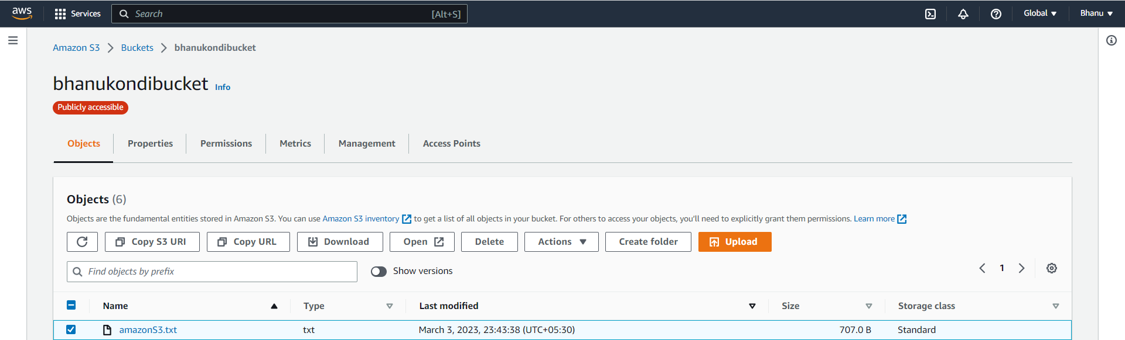

**Step 21:Click on copy Url.**

**the object reference url is copied to the clipboard.**

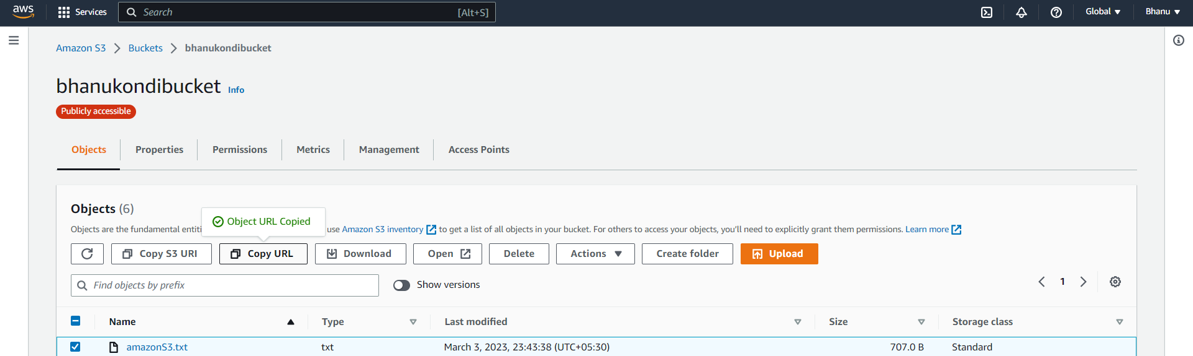

**The object reference url is**

[**https://bhanukondibucket.s3.ap-south-1.amazonaws.com/amazonS3.txt**](https://bhanukondibucket.s3.ap-south-1.amazonaws.com/amazonS3.txt)

Step 22:

Go to browser and paste the object reference url then you can see the content in the file that is uploaded as shown below.

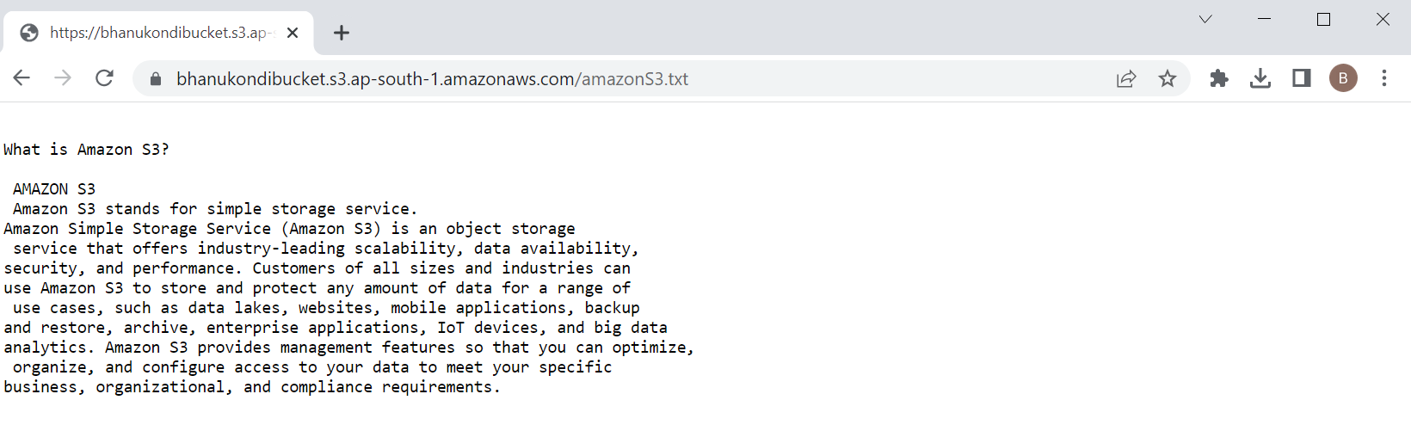

**Github link**

**https://github.com/kondibhanu9/aws_assignment_mar5**